**TerraProbe Soil Sampling Robot**

Critical Design Review

ME463: Senior Design

7 March 2025

**A Down 2 Earth (D2E) Company**

**Awadhoot Ghatge, Christopher Meyers, Jacob McKenrick, Lokesh Sriram, Sankaran Iyer**

# **Executive Summary**

The agricultural industry is striving to optimize crop productivity through data-driven solutions. However, traditional soil testing remains expensive, slow, and labor-intensive, limiting timely decision-making. Down2Earth addresses this gap with TerraProbe, a cost-effective, portable, and efficient soil analysis system. By integrating real-time data collection with a hybrid auger-core sampling mechanism, TerraProbe enables multi-depth soil profiling and instant insights, empowering farmers to make informed decisions.

TerraProbe consists of two core components: a soil-sampling robot and an integrated testing probe. The lightweight 35-pound robot features a rack-and-pinion mechanism, powered by two DC motors, to drive the sampling payload into the soil with precision. An ergonomic foot pedal assists in applying additional force as needed. The probe is equipped with sensors that measure moisture and NPK (Nitrogen, Phosphorus, Potassium) levels, displaying results via a user-friendly interface for real-time soil health assessment.

During the Critical Design Review (CDR), TerraProbe refined its focus on small and medium-sized farmers. Design enhancements include a more compact payload with a circular cross-section, ensuring smoother soil penetration and improved usability. Additionally, the economic strategy was revised to prioritize affordability for smaller farms. The revenue model includes device sales at $1,050 per unit, with recurring revenue from modular inner tubes and a data analytics subscription service to drive long-term profitability.

Our competitive advantage lies in three key areas:

1. Cost & Accessibility – Unlike expensive lab-based solutions, TerraProbe integrates automated on-site sampling and analysis, reducing costs and making high-quality soil testing accessible to smaller farms.
2. Efficiency & Speed – Traditional soil testing requires days to weeks for results; TerraProbe provides instant insights, allowing farmers to adjust their strategies in real time.
3. Ease of Use & Portability – With a lightweight, user-friendly design, the device requires minimal training, making it ideal for widespread adoption.

The CDR focused on manufacturability and reliability. Key improvements include shaft and gear failure analysis to optimize power transmission from motor to auger core, ensuring smoother and more consistent soil penetration. Additionally, soil analysis was refined to target soft clayey soils, leading to a revised motor selection for improved efficiency and adaptability.

With major design milestones completed—including finalizing the CAD model, selecting manufacturing methods, and conducting failure analysis—TerraProbe now moves into the Final Design Review (FDR) phase. Next steps include Finite Element Analysis (FEA) for structural optimization, tolerance drawings, component manufacturing, and prototype assembly. Following this, field testing will validate performance and refine operational efficiency.

TerraProbe’s vision is to revolutionize soil sampling with an on-demand, portable, and efficient solution, delivering real-time analytics across various soil depths. By providing accurate, data-driven insights, TerraProbe empowers agricultural professionals to optimize crop yields and enhance soil health management worldwide.

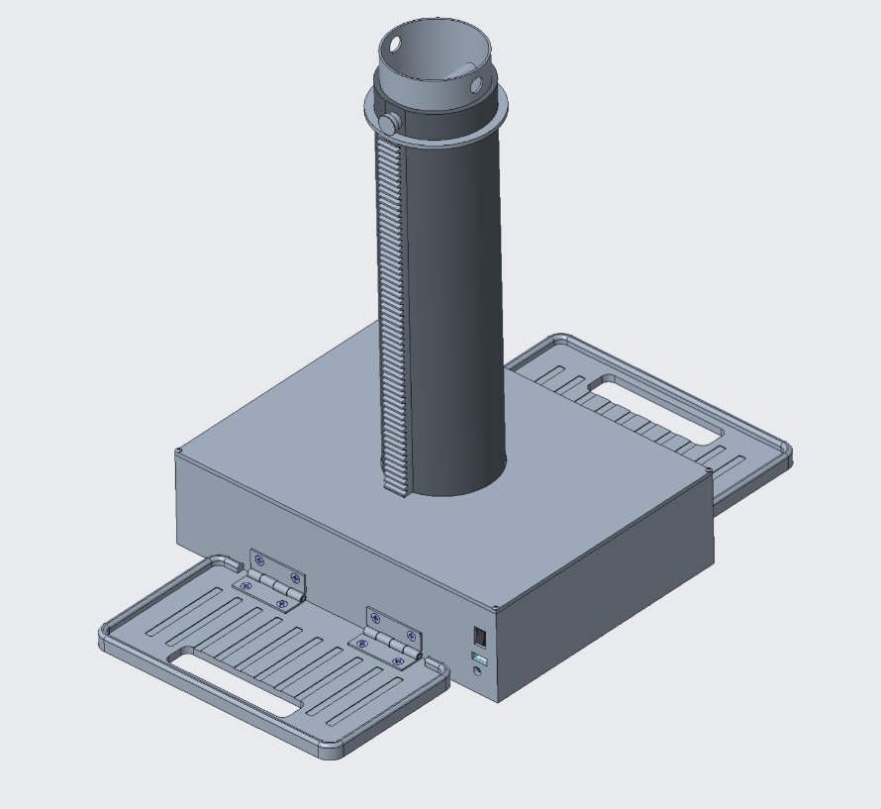

**Figure 1: TerraProbe Concept Design**

Table of Contents

Executive Summary 2

Introduction 6

I. Identifying the Problem 6

II. Understanding the Stakeholders & Market 6

III. System Design 9

IV. Analysis & Simulations 18

V. Failure Modes & Risk Management 23

VI. Manufacturing & Sourcing Strategy 24

VII. Testing & Validation Plan 26

IX. Conclusion & Next Steps 29

APPENDIX 30

A.1 - Project Management 31

A.2 – Business / Marketing 35

A.3 – Design Process 45

# **Introduction**

# **Identifying the Problem**

The Down To Earth (D2E) team has identified a significant gap in the soil sampling market. Soil sampling plays a crucial role in agriculture, environmental monitoring, and geotechnical engineering. Reliable soil analysis provides insights into soil composition, fertility, contamination levels, and mechanical properties. However, traditional soil sampling and testing methods involve several challenges including inconsistencies in sample collection due to heavy bulky equipment, soil contamination between depth layers, and inefficiencies in manual operations. These limitations hinder the accuracy of soil assessments, leading to suboptimal decision-making in farming, land development, and environmental remediation. The market consists of either manually operated soil sampling equipment or complex, bulky machinery that require skilled access to greater soil depths. This presents an opportunity for an intermediate solution, a device that is portable, efficient, and capable of burrowing and collecting soil samples at multiple depths without compromising sample integrity (Refer to Appendix A.2)

To address this gap, we intend to build TerraProbe, a soil sampling robot specifically designed for small to mid-sized farmers who cultivate a limited variety of crops. Unlike large-scale agribusinesses with access to industrial-grade soil testing solutions, these farmers often lack affordable, efficient tools for precise soil analysis. TerraProbe aims to bridge this gap by providing an accessible, easy-to-use, and data-driven solution tailored to their needs. The system will efficiently burrow into the soil, extract samples at various depths, and provide a soil testing probe that collects real-time data through an integrated dashboard, displaying critical soil properties such as NPK (Nitrogen, Phosphorus, Potassium Concentrations) and moisture. Our vision is to revolutionize soil sampling and monitoring by delivering an on-demand, portable, and labor-efficient solution that offers real-time analytics across different soil depths. The device will not only provide a method to accurately excavate and extract soil samples but also provide data on-site instead of requiring testing at the lab. TerraProbe is a tool not only for farmers and agronomists but eventually has the potential to become a daily household solution that will enable data-driven decision-making to optimize crop yield, improve construction planning, and promote sustainable land management practices globally.

# **Understanding the Stakeholders & Market**

In the agricultural market, the need for more efficient, accurate, and accessible soil testing is becoming increasingly important. Our primary and target consumers are farmers and agronomists who require the collection of soil samples to analyze properties at various depths. Specifically, TerraProbe’s target consumer is designed primarily for small to mid-sized farmers who cultivate a few crops and often lack affordable, efficient soil testing solutions. Currently, according to a study by Crop Nutrition, only 10-15% of fields in small-grain farming regions undergo annual soil testing, largely due to the high cost and time commitment associated with third-party services. With soil testing prices varying by region and increasing due to rising fuel costs, many farmers forgo testing altogether, leading to suboptimal soil management and lower crop yields for many small-scale farmers.

The global soil testing market, valued at $5.5 billion in 2023, is experiencing significant growth, driven by the expanding adoption of precision agriculture technologies.

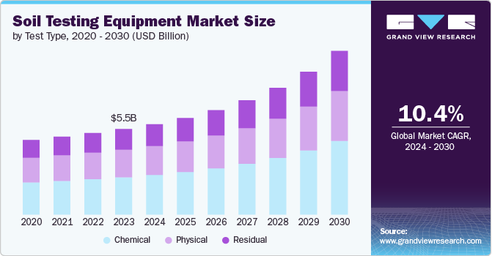

**Figure 2: Market Growth**

As shown in Figure 2, with a compound annual growth rate (CAGR) of 10.4%, the soil testing market presents a strong opportunity, particularly given the inefficiencies of existing solutions. In the U.S. alone, there are 1.8 million total farmers. Roughly 671,000 of these are small to medium-acreage farms who align with TerraProbe’s target consumers. Assuming a conservative 20% adoption rate, this represents a potential market figure of 134,200 units. TerraProbe’s innovative offerings—combining autonomous soil burrowing system with integrated data collection and real-time testing probe—creates multiple revenue streams, including unit sales and recurring subscription services for advanced analytics. With rising costs and labor-intensive processes limiting widespread soil testing, TerraProbe offers an efficient, affordable, and scalable solution, making it well-positioned to address this growing market demand.

|  |  |  |
| --- | --- | --- |
| [**AMS Soil Probes**](https://www.ams-samplers.com/soil-probes/?srsltid=AfmBOooCz73JXL5CJCZstnSxcL71dH0DrRpJWqvqxQZTRj4dp-7FCFa0&utm_source=chatgpt.com)  7/8" X 21" Soil Probe w/ Handle, 5/8" Thread | A green and yellow vehicle  Description automatically generated[**WintexAgro 1000 Automatic Soil Sampler**](https://wintexagro.com/products/wintex-1000/?utm_source=chatgpt.com) | A tractor in a field  Description automatically generated[**Amity Technology Soil Sampler**](https://www.amitytech.com/crop-management-tools/soil-samplers/) |

**Figure 3: Benchmark Models**

Figure 3 showcases a few examples of the benchmark solution. Currently, market alternatives range from low-cost, manual soil probes to high-end automated systems. For instance, AMS soil probes, which are simple and cost-effective, are manual and lack depth accessibility, automation, and data integration. On the other end of the spectrum, products like the Amity Technology Soil Sampler are highly automated, capable of sampling to depths of 48 inches, but they come at a high price range of $3000-$6000 and lack portability or real-time data analytics as they require mounting on vehicles and third-party data acquisition systems. While the WintexAgro 1000 provides some automation, its shallow depth capacity (up to 30 cm), bulky and heavy equipment, and lack of integrated data analysis further highlight the gaps in existing solutions.

A core feature and vision of our product, TerraProbe, is the real-time data collection and autonomous soil sampling, especially in challenging soil conditions like soft clay. This feature not only differentiates TerraProbe but also positions it as an asset for both precision agriculture and other industries such as construction and environmental research. Unlike AMS probes or the Wintex 1000, TerraProbe will combine portability (≤ 25 kg), autonomous operation, and multi-depth sampling (up to 12”) with integrated sensors for moisture and NPK concentrations, offering real-time data analysis that none of the benchmark products can provide. While farmers are the core target, firms in the geotechnical investigation space, including companies like Fugro and AECOM, as well as environmental monitoring organizations like NASA and the USDA, also stand to benefit from TerraProbe’s capabilities.

TerraProbe will be launched in the market to balance affordability, go-to-market strategy, and long-term profitability through a dual revenue model. Our product strategy leverages a product line and services business model. TerraProbe consists of two core components: the soil burrowing robot and the testing probe, both of which we will sell at a low profit margin of approximately 25% to remain competitive and drive adoption. With an estimated production cost of $800-$850, we will price TerraProbe between $1000-$1100, making it an accessible and cost-effective solution for small and medium-acreage farmers.

To ensure sustained revenue and customer retention, we will leverage a service-based model with two key streams:

1. Modular Inner Tubes – These replaceable storage units house soil samples within the robot and will be sold as recurring items to test multiple times.
2. Analytics Subscription – Farmers can access real-time soil health insights through our integrated software platform, offering actionable data for precision agriculture.

This strategy not only lowers the initial barrier to entry but also establishes a recurring revenue stream, ensuring long-term engagement with customers. By offering a competitively priced hardware solution alongside indispensable consumables and data services, we create a scalable go-to-market approach that aligns with the needs of small-scale farmers while positioning TerraProbe as a cost-efficient, high-value investment in soil testing. Further economic projections and financial modeling are detailed in the Economic Analysis section below (Additionally, refer to Appendix A.2 for more details on Market Analysis).

# **System Design**

As we are developing the design of TerraProbe, the benchmark models had a common theme such as high cost, low portability, high operational complexity, and limited depth accuracy, which can be prohibitive for small to medium-sized farms or non-experienced users.

The development of TerraProbe focuses on addressing key challenges faced by the current benchmark models. TerraProbe aims to overcome these limitations by ensuring affordability, maintaining product development costs and sale prices under $1000 to allow for competitive market pricing. Additionally, the device is designed to be lightweight, weighing no more than 25 kg, and compact, with maximum dimensions of 23” W x 20” D x 14” H, ensuring easy transportation and storage. Autonomous operation is a key feature, allowing users to collect soil samples effortlessly, with the ability to extract up to 18 inches of soil while integrating real-time analysis for moisture, salinity, and temperature. The system is engineered to operate in diverse environmental conditions, functioning effectively between 0°C and 50°C, while maintaining a low-maintenance design that requires servicing only after 100 hours of operation. A user-friendly dashboard or web application is also integrated to provide real-time data visualization on mobile and desktop devices. A few customer requirements, engineering requirements, and respective importance ratings are laid out in Table 1 below. (Refer to Appendix A.3 for more information on customer requirements.)

**Table 1: Translating Customer Requirements to Engineering Requirements**

|  |  |  |
| --- | --- | --- |
| Customer Requirement | Engineering Requirement | Importance Rating (1-5) |
| Safety | Automatic shut-off if the device malfunctions or detects an obstacle | 5 |
| Portability & Lightweight Design | Device must be < 25 kg and compact to ensure portability | 5 |
| Autonomous Operation | Must operate and collect soil without manual force for at least 2 hours of continuous operation | 3 |
| Accurate Multi-Depth Soil Sampling | Collect up to 18” of soil profile without mixing | 5 |
| Integrated Real-Time Data Analysis | Equipped with sensors for moisture (±5%), salinity (±5%), and temperature (±1°C), with data processed in under 30 seconds. | 3 |
| Cost-Effective and Affordable | Prototype development costs $600-1000 per unit, Sell Price Under $1500 | 4 |
| Durable for Diverse Environments | Operable between 0°C and 50°C, Water-Resistant | 4 |
| Low Maintenance | Maintenance required every 100 hours of operation | 3 |
| Depth Accessibility | Can collect soil samples from at least four depths: 0-2 in, 2-4 in, 4-8 in, 8-12 in. | 5 |

* 1. **Core Design Concept**

The design of TerraProbe has been formulated adhering to the design requirements and constraints listed above. TerraProbe is designed to be compact with dimensions of 10” wide by 12” long by 17” tall. Additionally, it weighs 35 pounds, which is relatively light compared to alternative solutions, which can be as heavy as several hundred pounds. The soil sampling device is motor-controlled and provides real-time data analysis. Addressing challenges such as high cost, portability, and operational complexity in existing models, the system is structured around a rack and pinion mechanism that drives a soil-collecting payload into the ground. The overall design consists of a sturdy base housing all motors, gears, and electrical components, along with an outer shell and an inner payload chamber responsible for soil collection. The device features foldable foot pedals to provide additional downward force, a removable top lid for easy maintenance, and a built-in limit switch to prevent the payload from travelling too far into the ground. Additionally, the system includes an integrated soil testing probe, which analyzes the extracted sample for key parameters such as moisture, Nitrogen, Phosphorus, and Potassium content. The combination of mechanical efficiency and smart sensing technology ensures that TerraProbe delivers accurate, multi-depth soil data in a user-friendly and portable manner.

Key mechanical design features include:

* Rack and pinion – Drives payload and outer shell into the ground
* Foldable foot pedals – Allow users to apply downward force for improved penetration.
* Removable top lid – Provides easy access for maintenance and cleaning.
* Limit switch mechanism – Prevents over-extension of the outer shell during operation.



**Figure 4: TerraProbe Full Assembly**

* 1. **Soil Collection System**

At the heart of TerraProbe’s soil collection mechanism is a two-part penetration system consisting of an inner payload and an outer shell. The inner payload is a 16.5-inch-tall chamber with a 1/16” thickness to reduce soil displacement. Originally, the payload had one-way doors at the bottom to prevent dirt from sliding out on the way back out of the ground. However, this feature was discarded because commonly soil is cohesive at depths around 12” and deeper. In addition, the lack of doors on other soil bore is an industry standard which saved the team time and money prototyping one-way doors. The outer shell, which encases the payload, contains gear racks mounted vertically along its sides and a chamfered base to facilitate smooth soil entry. The payload is locked into place on the shell using a quick release pin, so that the payload does not slide relative to the shell during the entry phase. Once the sample is collected, the payload can be removed from the outer shell, preserving the soil layers for analysis.

The rack and pinion system are powered by two DC motors housed within the base compartment. A ¾” face-width gear engages with the rack, driving the outer shell and payload downward. Ball bearings support the rotating axles, ensuring smooth and efficient motion. As the probe advances, soil enters the inner payload chamber, maintaining its stratified structure. Upon retrieval, the payload can be probed through 5 horizontal slits to measure soil properties at varying depths. The system is designed to operate autonomously, enabling users to collect multiple-depth samples without manual force, ensuring accurate soil profiling with minimal effort.

The central penetration system consists of two main components:

* Inner Payload: A 16.5-inch chamber that collects soil as the probe is pushed into the ground.
* Outer Shell: Houses the gear racks and structural components, featuring a 45-degree chamber at the bottom to facilitate smooth soil penetration.

The inner payload is removable, allowing soil to be analyzed both in-field using sensors or sent to a lab for further testing.

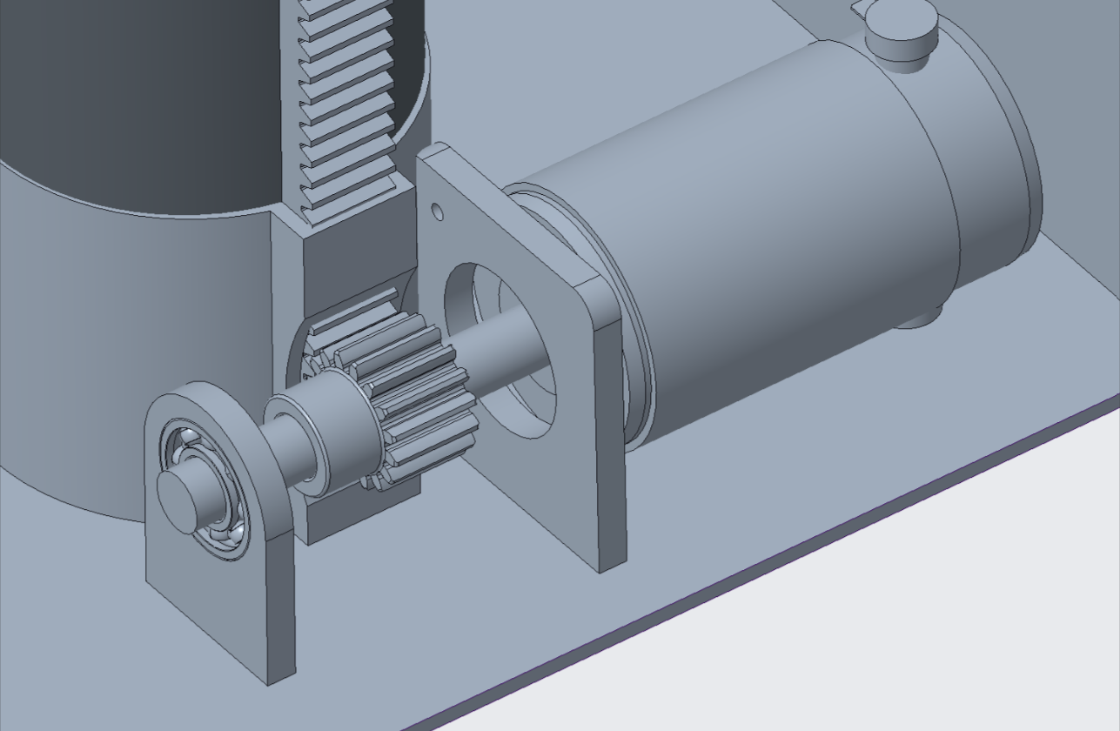

**Figure 5: Rack & Pinion, Motor, Shaft System**

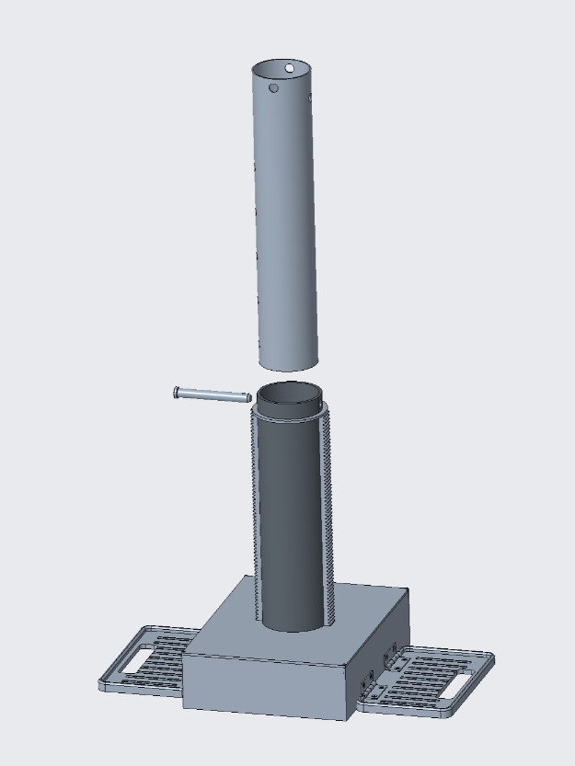

**Figure 6: Inner & Outer Payload**

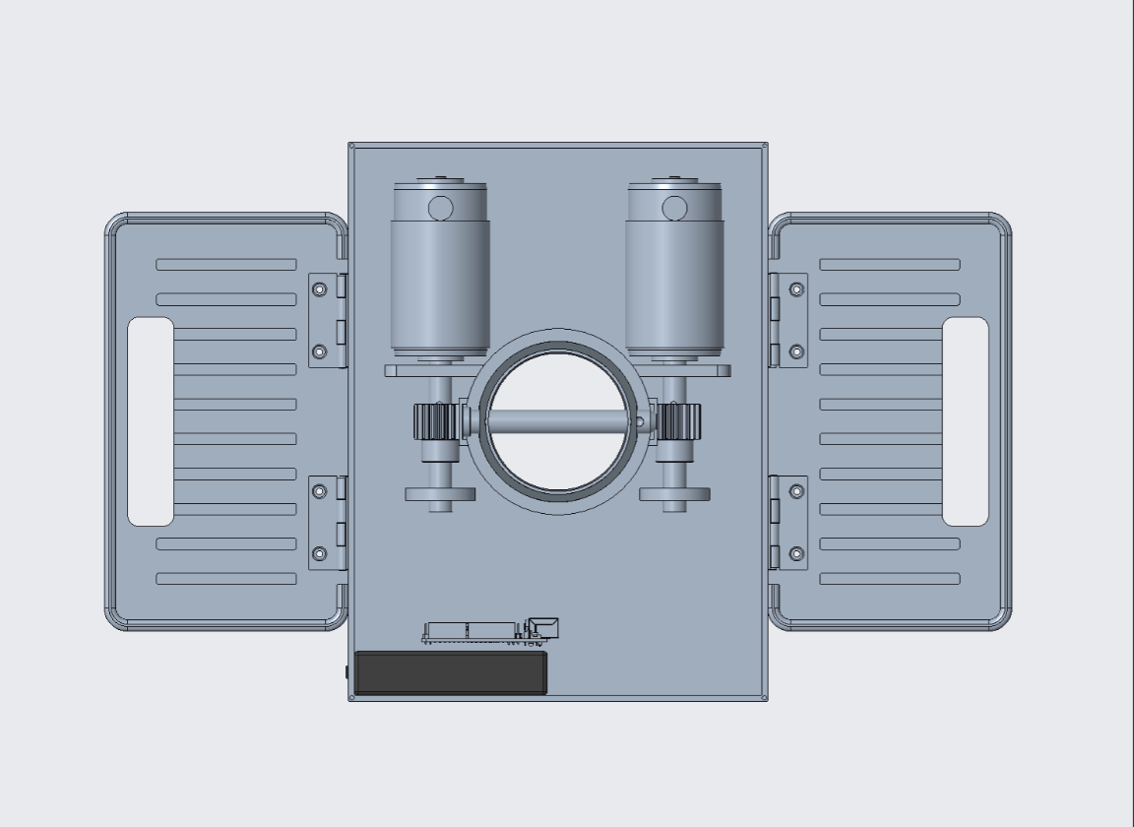

**Figure 7: Inner workings Top View**

Motors serve as the main driving mechanism for the rack and pinion system, allowing the Terra Probe to penetrate through the ground. Based on calculations from the analysis section of this report, a low-torque motor with 35W power and 30 RPM was required. Consequently, two 12V DC motors (Hitiland, DC Gear Motor, 12V, China) operating at 30 RPM were selected to operate the system. To control these motors, an L298N Dual H-Bridge motor driver module was used, allowing simultaneous control and power distribution to both motors. The system was programmed using an Arduino Uno microcontroller for computing power and ease of use. A 12V Talentcell rechargeable lithium-ion battery (3000mAh) powered the motors while also supplying 5V to the Arduino Uno. For user functionality and safety, a switch was incorporated to turn the rack and pinion system on and off, including emergency shutdown capability. A red button is also attached to the designed to act as a limit switch, preventing the rack and pinion from digging once the max height of the payload is reached.

The circuit diagram below illustrates the motor control system, detailing all components mentioned above along with their pin connections to the Arduino. Additionally, a barrel plug connects the battery to the motor driver for seamless wiring integration.

**Figure 8: Motor Driver Control System**

* 1. **Soil Testing Probe**

To complement the mechanical sampling system, TerraProbe integrates an advanced soil testing probe for in-field analysis. This probe is designed as a compact module with multiple sensors extending from its base, allowing insertion through pre-designed slots in the inner payload chamber. The primary sensing unit is the Taidacent RS485 Soil Sensor, which measures nitrogen (N), phosphorus (P), and potassium (K) levels, essential for evaluating soil fertility. Additionally, moisture and salinity sensors are included, providing real-time assessments with accuracy levels of ±5% for moisture and salinity and ±1°C for temperature.

In the CAD model below, we can see the PLA casing built to house our electronic components. In the casing we include our Arduino Mega, battery, SD card holder, and transceiver module. The top of our probe features a dual-segment display designed to show the NPK, moisture, and salinity data. The casing dimensions are 3.0” x 6.5” x 2.0” where the three inches of the probe extending out.

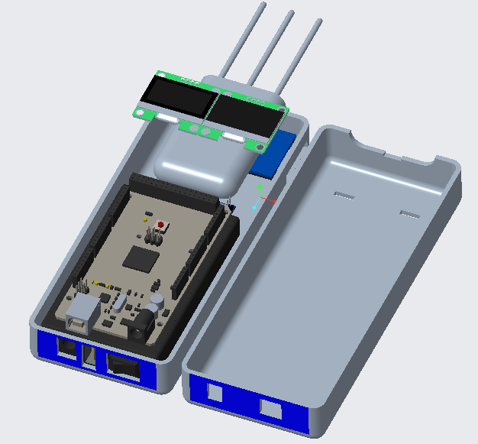

**Figure 9: CAD Model of Testing Probe (with Arduino and Battery)**

The TerraProbe system is designed to collect, process, and visualize soil data in real time, integrating both hardware and software components. The data acquisition process begins with embedded sensors connected to an Arduino Mega, which captures and processes real-time soil readings. These readings are stored on an SD card module, ensuring data integrity across multiple depths. The probe's consumable inner payload design features slits at five distinct depths (1", 3.5", 6", 8.5", and 11") allowing precise multi-layer soil analysis. Depth selection is controlled through five physical buttons on the probe, enabling structured data collection across all layers. To achieve the project objectives, the following components were used: Arduino Mega, OLED display, NPK soil sensor, soil moisture sensor, transceiver module, SD card module, and a 5-in-1 analog button.

The Arduino Mega was selected due to its superior computing capability and the availability of multiple pin outputs, making it suitable for this multi-sensor data acquisition system. A 12V battery was used to power the NPK soil sensor while also providing a regulated 5V supply for the Arduino Mega. The NPK soil sensor, which measures nutrient levels in the soil (Nitrogen, Potassium, Phosphorus), required an RS485 communication protocol. To facilitate this, a transceiver module was used to convert Arduino’s UART signals into RS485, enabling proper interfacing. Additionally, a capacitive soil moisture sensor was integrated to measure the water content in the soil.

For user interaction, a 5-in-1 analog button was implemented to control the data collection process. The system's operational status and data collection updates were displayed on an OLED screen. Once data was acquired, it was stored in a .csv file, which recorded measurements at different depths. The SD card module enabled the transfer and storage of this data onto an SD card, ensuring convenient access for further analysis.

By integrating these components, a data acquisition system was developed as a secondary function of this project. The following diagram illustrates the wiring connections and pin assignments between the Arduino and the various sensors.

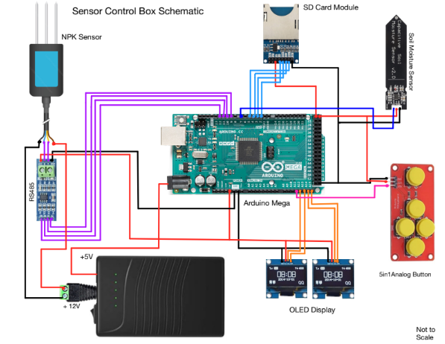

**Figure 10: Data Acquisition System**

Once data collection is complete, the data visualization framework is initiated through an automated Python executable file stored on the SD card. This executable reads the recorded data, processes it using Pandas library, and generates preliminary analytics. The Streamlit library serves as the frontend, enabling a dynamic and interactive dashboard where users can visualize soil properties and trends. Each execution of the program clears the previous data, preparing the system for the next round of testing.

Beyond basic data visualization, TerraProbe would like to incorporate predictive analytics to provide insights and drive decision-making such as expected yield projections under current soil conditions vs. an optimized scenario with recommended nutrient adjustments. We can use NPK heatmaps that highlight nutrient deficiencies, paired with overlay recommendations for precise fertilizer application rates.

This structured data architecture ensures efficient data collection, automated processing, and real-time insights, a preliminary design of the dashboard is shown below to emulate the end-goal.

**Figure 11: Sample Dashboard Set-up**

# **Analysis & Simulations**

To ensure that TerraProbe operates efficiently and reliably, a series of engineering analyses and simulations were conducted. These analyses guided the selection of key mechanical and electrical components, ensuring optimal performance under real-world conditions. The primary areas of analysis include motor selection, gear ratio calculations, shaft design, bearing selection, and structural integrity assessments. Additionally, failure analysis was performed to evaluate potential weak points in the design and improve durability.

* 1. **Motor Selection and Torque Analysis**

The mechanical work required to run the device to reach the required depth needs to be considered. First a free body diagram was drawn to determine all the forces that would act on the payload.

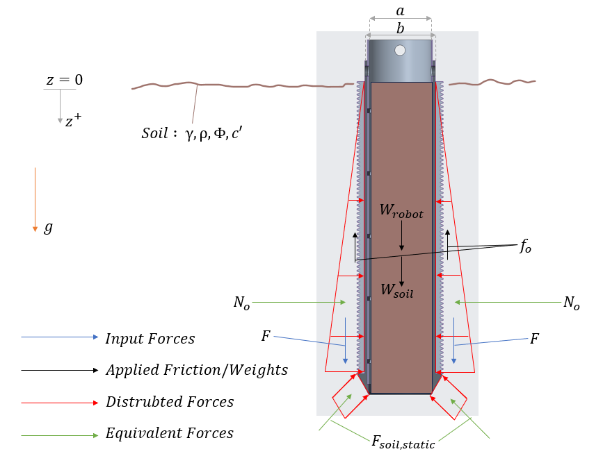

**Figure 12: Free Body Diagram**

Now the main forces are along the Z direction, and this will be the direction in which the rack will be provided force. The following Force balance equation can be used to determine the required force $F$.

$\sum{F_{z}=2F+f_{i}+W_{robot}+W_{soil}}-f_{o} -F_{soil_{static}}=\left(m+M\right)\ddot{z}$ $\left(1\right)$

Where $f_{i}$ is the internal frictional force, $W_{robot}$ is the weight of the robot, $W_{soil}$ is the weight of the soil collected, $f_{0}$ is the external frictional force, $F_{soil_{static}}$ force acting upwards modelled as a buoyancy force, $m$ is the mass of the soil collected, $M$ is the mass of the robot, and $\ddot{z}$ is the acceleration of the body

However, the frictional forces and desired motion profile are unknown. The external frictional forces were calculated according to the Rankine Theory (Earth Pressure Theory and Application, Purdue University, n.d).The internal friction force was considered negligible due to the incorporation of a lip as the soil enters the payload. Then a desired motion profile was created such that the robot would reach the required depth in 2 minutes. The calculated required force was 923.4 N (213.84 lbf) for stiff cohesive soils. (Refer to the Appendix A.3 to see the calculations).

To provide the same force, a 35-watt, 12-volt motor needs to be run at 27.5 rpm (AGMA Calculation for the same can be seen in Appendix A.3 and exact motor identified in BOM). However, if the design needs to be implemented on more cohesive soil, a gear box can be used to increase the gear ratio and hence the torque provided to the system.

* 1. **Gear System and Load Distribution**

The rack and pinion system in TerraProbe is the mechanism by which we convert rotational motion into vertical translation. It is central to consider multiple design details such as, but not limited to, gear pitch, face width, material selection, and tangential load. Aside from design considerations, the rack and pinion interface need to be designed for precise assembly – to ensure that the gear tooth are always in contact.

As the gear will go through a larger number of cycles than the rack, yield and fatigue analysis need to be done on the pinion. AGMA standards were used to conduct the same. The pinion gear would experience two forces: the Tangential and the perpendicular force. This can be seen in the free body diagram below

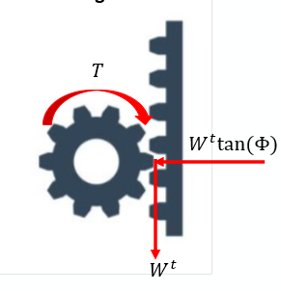

**Figure 13: Pinon Rack Interface Forces**

Since the device needs to be portable, the pinion chosen had a pitch diameter of 1 inch, a pitch of 16 teeth/inch, and face width of 0.75 inch. Hence it follows that the rack would have the same pitch and face width as the pinion. Using these properties the gear contact ($σ_{c}$) and bending stresses ($σ_{b}$) on the gear teeth were calculated (Refer to Appendix A.3 for the same)

$$σ_{c}= 62627.64 psi \left(or\right) 62.6 kpsi$$

$$σ_{b}=26561.67 psi \left(or\right) 26.7 kpsi$$

Now that there is an estimate of the stresses the gear teeth will experience, the team needed to choose pinions and racks that meet the mechanical and financial requirements while being easy to procure. The gear chosen was made from 1144 hardened steel and the rack chosen was made from 1215 steel (part numbers 5172T63 and 5174T12 from McMaster Carr respectively). Now that the parts were chosen, the bending ${(S}_{T})$ and wear ${(S}_{H})$ factor of safety were calculated

$$S_{T}=3.49$$

$$S_{H}=1.81$$

Since both factors of safety are well above 1.5, the part selection was justified. The full calculation to determine the parameters that influence the factor of safety, such as geometry factors, load factors, and surface factors, can be seen in Appendix A.3.

* 1. **Shaft, Key, and Bearing Selection**

The shaft design is critical to the functionality and reliability of the TerraProbe, as it connects and mounts the motor to the gear system while ensuring smooth and efficient power transmission. A ball bearing is mounted at the end of the shaft to enhance stability and safety, preventing misalignment or excessive wear over time. The shaft, with a length of 3 inches and a diameter of 0.5 inches, experiences three primary forces: assembly reaction forces from the motor mount acting at 0.375 inches, tangential loading due to the gear, and shear forces from rotational motion. The tangential loading force, determined through the motor selection and torque analysis, was calculated to be 213.84 lbf.

To ensure durability and mechanical integrity, the shaft is made from AISI 4140 steel, providing high strength and fatigue resistance. The analysis yielded a fatigue factor of safety of 4.4 and a yielding factor of safety of 8.8, both significantly exceeding the required design factor of 1.5. This additional safety margin accounts for unforeseen stresses that may arise during operation. The bearing loads, calculated at 89.62 lbf in the y-direction and 32.62 lbf in the z-direction, guided the selection of appropriate bearings. Based on these loads, McMaster-Carr bearings (60355K291) were chosen, offering a static load capacity of 530 lbf, a dynamic load capacity of 1140 lbf, and a maximum operating speed of 25,000 RPM. These design considerations ensure the shaft assembly operates with high efficiency, minimal wear, and long-term reliability under varying soil conditions. Detailed shear force, bending moment, and combined bending analyses are included in the appendix for reference.

**Figure 14: Shaft Design Free-Body Diagram**

The key design for the TerraProbe's shaft is important to ensure proper power transmission and preventing relative rotation between the shaft and its connected components. A square key with dimensions of 0.125 inches for both width and height were selected based on the shaft diameter of 0.5 inches, following AGMA recommendations. The key length was determined to be 0.25 inches, satisfying both shear and crushing safety requirements with a factor of safety of 1.5. (Refer to Appendix A.3 to for the AGMA equations utilized)

The key material chosen was AISI 1045 Carbon steel, providing adequate strength to withstand the calculated torque of 106 lbf. This design ensures that the key can effectively transmit power from the motor to the gear system without failure due to shear or crushing stresses. The selected key dimensions (w = 0.125 in, h = 0.125 in, l = 0.25 in) correspond to McMaster-Carr Part # 98870A090, which offers standardized, readily available components for ease of manufacturing and maintenance.

# **Failure Modes & Risk Management**

The Failure Modes and Effects Analysis (FMEA) process was conducted to identify, evaluate, and mitigate potential failure modes in the TerraProbe system, including the soil burrowing and testing probe components. This analysis assesses key components, their possible failure modes, effects, causes, and current controls while assigning severity (SEV), occurrence (OCC), and detection (DET) rankings to calculate the Risk Priority Number (RPN). By prioritizing risks based on RPN, targeted mitigation actions were developed to improve reliability and performance.

The highest-risk areas identified include battery depletion (RPN: 270), motor overheating (RPN: 240), and data transmission failures (RPN: 240), which could lead to critical malfunctions or system shutdowns. To address these, optimized power management strategies, enhanced thermal control for motors, and more robust data transmission methods (e.g., upgrading to an Arduino Mega and switching to SD cards) were proposed. Additionally, sensor failures (RPN: 180) and soil water ingress (RPN: 180) pose risks to data accuracy and device longevity, necessitating improved sealing, shock-absorbing mounts, and enhanced sensor protection measures.

Following mitigation efforts, the revised RPN values show a significant reduction across all failure modes, particularly in high-risk areas such as power system failure (reduced from 270 to 54), overheating (from 240 to 54), and mechanical couplings (from 240 to 63). These improvements indicate a more robust system with better durability, maintainability, and operational efficiency. Moving forward, implementing these changes will enhance TerraProbe's reliability in real-world agricultural conditions, ensuring consistent and accurate soil data collection.

# **Manufacturing & Sourcing Strategy**

For this project, a careful make-or-buy analysis was conducted to determine the most efficient and cost-effective approach. The decision was made to manufacture the inner and outer payloads, sensor probe casing, and foot pedals in-house due to their specific shape requirements and custom design needs. Conversely, sensors, electronics, batteries, gears, shafts, and motors will be sourced externally. The gears, for example, involve a complex manufacturing process that would be costly to replicate in-house, while precision-engineered components like motors and sensors require specialized expertise and are best purchased.

**Table 2. Make or Buy Table with Justifications**

|  |  |  |
| --- | --- | --- |
| **Component** | **Make/Buy** | **Justification** |
| Inner Payload | Make | Requires specific shapes that are best controlled in-house. |
| Outer Payload | Make | Custom design requirements make in-house production preferable. |
| Sensor Probe Casing | Make | Custom casing ensures proper fit for sensors and electronics. |
| Foot Pedals | Make | Custom design is required to meet project needs. |
| Sensors | Buy | Precision components that are not feasible to manufacture. |
| Electronics | Buy | Specialized components requiring external sourcing. |
| Batteries | Buy | Standardized and regulated components best sourced externally. |
| Gears | Buy | Complex manufacturing process and high production cost. |
| Shafts | Buy | Bought at standard size and manufactured as needed by ME shop. |
| Motors | Buy | Precision-engineered components requiring external expertise. |

The assembly process will follow a structured approach, beginning with the construction of key subassemblies before final integration. The inner and outer payloads will be manufactured and assembled internally, ensuring they meet custom specifications. The base will be machined at the Purdue ME machine shop or RMS, leveraging their capabilities for precision fabrication. The sensor probe casing will also be assembled in-house to ensure proper integration with the electronic components. Once these subassemblies are complete, they will be integrated into the final system, with electronics, sensors, motors, and batteries installed into their respective casings, followed by the attachment of foot pedals and mechanical linkages.

To facilitate smooth procurement, orders for the electronics and motors have already been placed. An additional order for components from McMaster Carr will be placed within the next few weeks. The overall budget allocation for this phase is $448.19, ensuring financial constraints are met while maintaining production goals. The Bill of Materials (BOM) includes key components such as sensors, electronics, motors, shafts, and fasteners, with sourcing decisions made based on lead time, quality, and reliability. The primary vendors for externally sourced components are Amazon and McMaster Carr, selected for their dependable supply chains and product availability.

# **Testing & Validation Plan**

The testing and validation plan ensures that all components and subsystems function as expected, meet design tolerances, and integrate seamlessly. By testing individual components before full system integration, the project aims to achieve reliable operation and long-term durability. The validation process consists of two key phases: component-level testing and system-level assembly testing. Each phase includes assessments of electrical, mechanical, and structural performance to confirm the reliability of the final system.

Component testing focuses on verifying the functionality, accuracy, and durability of individual mechanical and electrical elements. Motors are tested for speed control, encoder accuracy, and closed-loop performance using PWM signals and PI controllers. The controller for the same will aim to set a 2% settling time of ~1 second and a zero steady state error. Sensors, including NPK and moisture sensors, are calibrated with controlled soil samples and subjected to extreme conditions (their limits) for reliability testing. Display panels undergo testing to assess brightness, contrast, and readability under various lighting conditions. Mechanical components such as the shaft, gear, key, and rack-and-pinion system are measured for precision, rotational smoothness, and torque resistance. The structural integrity of casings and pins is validated through environmental stress tests, including submersion in soil, vibration analysis, and force testing for proper fit.

System and assembly testing evaluate how well individual components interact when integrated. The motor-pinion-rack system is tested under load to ensure smooth forward and backward movement while minimizing backlash and misalignment. Soil collection is assessed in different soil conditions to validate efficiency, consistency, and automation accuracy. Weight testing confirms that the system remains within design limits under various operational states, while probe and data analytics are examined for transmission accuracy, sensor drift correction, and reliability. Sub-assemblies are tested for fit, alignment, and environmental resilience before final system integration, ensuring that all components work together seamlessly.

By combining component-level validation with full system testing, this approach ensures that every subsystem operates as intended under real-world conditions. The structured methodology minimizes failure risks, enhances performance reliability, and guarantees that the final design meets functional, environmental, and operational requirements. Through rigorous evaluation and iterative refinement, the project aims to achieve a robust, high-performing system suitable for its intended application.

1. **Economic Analysis**

As we are planning the engineering and design feasibility of TerraProbe, it is also important to identify the market size and assess the economics of TerraProbe. TerraProbe is strategically positioned as an intermediate-tier product, bridging the gap between low-cost, manual soil sampling tools and high-end, fully automated solutions that are often prohibitively expensive for small to mid-sized farms. In the first year, TerraProbe’s focus will be entirely on setting up manufacturing and research & development (R&D) infrastructure, with an estimated investment of $10 million. During this period, no sales will be made as TerraProbe will refine its design, establish supply chains, and develop the proprietary analytics platform.

The U.S. market presents a significant opportunity, with approximately 671,000 small- to medium-sized farms that could benefit from soil burrowing and real-time soil analysis. Our long-term goal is to capture 20% of this market over ten years, equating to 134,200 units sold. In the first year of sales, we plan to introduce 5,000 units into the market and gradually scale up production, reaching an annual sales volume of approximately 35,000 units by Year 10. The TerraProbe device, including both the soil burrowing robot and testing probe, costs $832.93 to produce. To remain competitive, we will sell the product at a 25% gross margin, pricing it at $1,050 per unit. However, the primary source of profitability will come from our service-based model of consumable inner tubes and analytics software to ensure customer retention and recurring revenue. To maximize long-term profitability, we will introduce two key recurring revenue streams: consumable inner tubes and an analytics subscription service. The consumable inner tubes, which store soil samples within the robot, cost $84.24 to manufacture and will be sold at a 50% gross margin for $130 per unit. Additionally, our analytics platform will provide farmers with actionable soil health insights for a subscription fee of $12 per month per user, with an annual application maintenance cost of $100,000. A breakdown of the estimated total revenue and cost has been projected for the first 10 years. While majority of the revenue still comes from selling the TerraProbe device, the consumable inner tubes and analytics software drives the profitability of the company.

**Figure 15: 10-Year Revenue & Cost Projections**

At full market penetration, TerraProbe is projected to generate approximately $50 million in annual recurring revenue by Year 10, firmly establishing itself as a key player in the precision agriculture industry. TerraProbe projects to break even between Years 4 and 5 and the 10-year return on investment (ROI) is projected to be around 33%, demonstrating the financial sustainability of our business model. By offering a cost-effective yet highly advanced solution, TerraProbe is well-positioned to redefine real-time soil sampling for farmers seeking affordability, efficiency, and data-driven insights. (Refer to Appendix A.1 for more information).

# **Conclusion & Next Steps**

The TerraProbe project has progressed significantly, reaching a critical milestone in its development. After consulting professionals in soil physics, science, and mechanics, the team identified a key requirement for agricultural applications: collecting soil samples up to 12 inches deep. This shift brought a major change to the product design. By reducing the required sampling depth from 18 inches to 12 inches, the force needed for penetration decreased, while simultaneously reducing the payload weight. This, in turn, lessened the downward force contributing to soil collection, optimizing the system’s efficiency.

The team has successfully finalized the CAD model, determined the appropriate parts and manufacturing methods, and conducted extensive failure analysis to validate the design. These achievements have reinforced the integrity and feasibility of our innovative soil sampling solution, ensuring its alignment with engineering requirements and market expectations.

Moving forward, the project now transitions into the Final Design Review (FDR), where the final validation and implementation stages will take place. Key next steps to be addressed in the FDR include:

1. **Finite Element Analysis (FEA):** Conducting advanced structural simulations to assess mechanical performance, optimize load distribution, and ensure reliability under field conditions.
2. **Toleranced Drawings:** Creating detailed manufacturing drawings with precise tolerances to facilitate accurate part production and seamless assembly.
3. **Manufacturing of Parts:** Initiating the procurement and fabrication of components based on finalized specifications and sourcing strategies.
4. **Assembly of the System:** Integrating all manufactured parts into a fully functional prototype, ensuring alignment with design specifications.
5. **Field Testing:** Deploying the assembled system in real-world conditions to evaluate performance, validate data accuracy, and refine operational efficiency.

Throughout this phase, the team will closely monitor manufacturing feasibility, quality control, and potential design refinements. Additionally, risk assessments will be re-evaluated to proactively address any emerging challenges, ensuring the project remains on track for successful market introduction.

With these final steps to be completed in the FDR, TerraProbe is poised to deliver a scalable, high-performance soil sampling solution that meets the demands of agricultural professionals, construction firms, and environmental researchers alike.

# **APPENDIX**

# **A.1 - Project Management**

1. **Charter (Attached as Project_Charter_v2.xlsx)**

1. **Schedule (Attached as Project_Schedule_CDR.xlsx)**

1. **Preliminary Budget**

**The preliminary budget can be found on Economic_Analysis_CDR.xlsx file attached.**

|  |  |  |  |
| --- | --- | --- | --- |
| **Total Product Cost** | **Margin** | **Sell Price** | **Annual Revenue (10-Year)** |
| **$832.93** | **25%** | **~$1050** | **$60M** |

1. **Risk Register**

The file Risk_Register_CDR.xlsx is attached to the document.

# **A.2 – Business / Marketing**

1. **Market Analysis**

The global soil testing market is experiencing significant growth, driven by increasing demand for precision agriculture and environmental monitoring. Valued at $5.5 billion in 2023, the market is projected expand with a compound annual growth rate (CAGR) of 10.4% from 2023 to 2030 (Grand View Research, 2023). This growth is supported by various factors, including the rising need for sustainable agriculture practices, increasing environmental concerns, and the adoption of advanced testing technologies. The market can be segmented into three primary target areas: agriculture, construction, and environmental research.



**Figure 16: Soil Testing Market Projection**

The agriculture sector shows promising growth potential, with the global smart agriculture market valued at USD 22.65 billion in 2023 and expected to grow at a compound annual growth rate (CAGR) of 13.7% from 2024 to 2030 (Grand View Research, 2023). This growth is driven by increasing automation in commercial greenhouses, implementation of controlled environment agriculture (CEA), and the adoption of advanced technologies such as IoT and AI in farming practices. Key players in this segment include AGCO Corporation, Deere & Company, and Trimble Inc., focusing on precision farming applications such as yield monitoring, field mapping, and irrigation management. The market is also seeing innovations in livestock monitoring, smart greenhouses, and the integration of technologies like drones, sensors, and data analytics to optimize agricultural processes and improve productivity.

In the construction sector, the geotechnical investigation market is valued at $5.22 billion annually in 2025 and expected to reach $8.65 by 2030 with a CAGR of 10.62% (Mordor Intelligence, 2023). Companies like Fugro, Geocisa, and AECOM are prominent in this space, addressing critical requirements such as foundation stability assessment, environmental impact evaluation, and site suitability analysis.

**Figure 17: Geotechnical Instrumentation and Monitoring Market**

The environmental research segment is driven by increasing climate change research and growing environmental monitoring programs, with organizations like NASA Earth Science Division, USGS, and the European Environment Agency leading efforts in soil carbon sequestration, contamination tracking, and ecosystem health monitoring (IPCC, 2022).

Despite the market's growth potential, there are several technological limitations and customer pain points to address in soil testing. Current soil testing methods often have limited accuracy due to sampling procedures, lack real-time data integration, and involve high operational complexities. Soil sampling can be time-consuming and requires careful consideration of factors such as sampling depth, pattern, and timing (University of Massachusetts Extension ,n.d.)

To enter this market effectively, a focus on the precision agriculture segment, particularly targeting small to medium-sized farms (50-500 acres), could be a strategic approach. Pricing strategies could include an initial unit price of $1500-$1800, complemented by sales of additional soil collection tubes. Distribution channels may include agricultural equipment dealers, online direct sales, and presence at agricultural technology conferences. Potential revenue streams for new entrants in this market include product sales, additional parts services, maintenance contracts, and custom research and development partnerships. To stand out in this competitive landscape, we plan to focus on developing a solution that offer real-time data collection, autonomous operation, compact and portable design, and lower costs compared to existing solutions.

However, potential challenges in market entry include technology adoption barriers, initial high development costs, regulatory compliance in different markets, and competition from established players. Stakeholders in this market ecosystem include internal entities like D2E, our team, and Purdue University professors, as well as external parties such as farmers, soil scientists, chemists, construction workers, land surveyors, and geotechnical engineers. Government agencies like the Department of Natural Resources, USDA, EPA, and Global Soil Partnership also play crucial roles in shaping the industry landscape (USDA Economic Research Service, 2023).

In conclusion, the soil testing market presents significant opportunities for growth and innovation, particularly in addressing current technological limitations and customer pain points. Companies that can develop cost-effective, efficient, and user-friendly soil testing solutions stand to capture a significant share of this expanding market.

**Customer Analysis and Market Strategy**

Current technological limitations in the field present several significant challenges, including a restricted depth range for sampling, inadequate real-time data integration capabilities, and high operational complexity that requires specialized training and expertise. These technical constraints have created substantial barriers to widespread adoption and efficient implementation.

Customer experience has been particularly impacted by the time-intensive nature of manual sampling, which requires 2-4 hours per acre to complete. This is further complicated by the high margin of error in traditional methods, with sampling errors ranging from 30-40%. Additionally, the substantial equipment costs have made it difficult for smaller operations to adopt these technologies, while the limited capacity for real-time data analysis prevents users from making timely, data-driven decisions in the field.

The initial target market focuses on the precision agriculture sector, specifically targeting small to medium-sized farms ranging from 50 to 500 acres. The pricing strategy has been structured to be competitive and accessible, with initial unit prices set between $600-1000, complemented by subscription-based data services for ongoing support and analysis.

The distribution strategy will utilize multiple channels to reach potential customers, including established agricultural equipment dealers, direct online sales platforms, and presence at agricultural technology conferences. This multi-channel approach ensures maximum market penetration and accessibility for customers.

Revenue generation will be diversified across several streams, including direct product sales, data subscription services priced between $50-200 per month, maintenance contracts for ongoing support, and custom research and development partnerships with agricultural institutions and technology companies. This diverse revenue model ensures sustainable growth while providing value at multiple customer touchpoints.

**Benchmark Research**

**Table 3: Customer Requirement Comparisons of Benchmark Products**

|  |  |  |  |
| --- | --- | --- | --- |
| **Customer Requirements** | [**AMS Soil Probes**](https://www.ams-samplers.com/soil-probes/?srsltid=AfmBOooCz73JXL5CJCZstnSxcL71dH0DrRpJWqvqxQZTRj4dp-7FCFa0&utm_source=chatgpt.com)  7/8" X 21" Soil Probe w/ Handle, 5/8" Thread | [**WintexAgro 1000 Automatic Soil Sampler**](https://wintexagro.com/products/wintex-1000/?utm_source=chatgpt.com)   | [**Amity Technology Soil Sampler**](https://www.amitytech.com/crop-management-tools/soil-samplers/)   |
| Portability & Lightweight Design | Weight: ~1 to 3 lbs  Length: ~33 inches  Portable | Weight: ~48 kg, 105 lbs  Length: | Weight: ~210 lbs  Length: 36” |
| Autonomous Operation | No, Manual Operation | Designed for vehicle mounting, portable with vehicle. Semi-automated sampling when mounted on vehicle | Designed for vehicle mounting, portable with vehicle. Semi-automated sampling when mounted on vehicle |
| Accurate Multi-Depth Soil Sampling | Up to 24” in 3” increments | Up to 30 cm or 11.8” | 24” to 48” |
| Integrated Real-Time Data Analysis | No | No | Yes, but might not be real-time |
| Cost-Effectiveness & Affordability | $100-150 | Price not publicly listed, reports mentioned $8000 | $3000-$6000 |
| Durability for Diverse environments | Yes, Stainless Steel construction | Yes Designed for different soil types and conditions. | Yes |
| Low Maintenance | Yes, Simple design with minimal maintenance needs | No, requires heavy maintenance, such as components that might need to be replaced and repaired rom time to time | Maybe, requires standard maintenance, such as components that might need to be replaced from time to time |
| Depth Accessibility | Yes | Yes, adjustable depth | Yes |
| Dashboard or WebApp for Analytics | No digital integration | No | Yes, partners with FARMQOA controller for cloud-based data and testing systems. |
| Differentiated Soil Depth Sampling | No, manual operation limits precise depth differentiation | No, multiple operations must be performed at the same location | Yes, higher level models available with multiple depth settings |

**Comparison of Benchmark Products to Terra Probe**

1. **Alignment with Problem Definition**:
   * Existing products partially address the need for efficient soil sampling and collection but fall short of delivering real-time analytics, multi-depth sampling, and soil mixing.
   * **AMS Soil Probes**: Simple manual tools, effective for basic sampling but lack depth accessibility, automation, and data integration capabilities.
   * **Wintex 1000**: Provides automation for shallow soil sampling but is limited to 30 cm depth and does not include real-time data analysis or visualization.
   * **Amity Technology Soil Sampler**: High-end automated sampling equipment capable of reaching greater depths (up to 48 inches) but lacks portability, affordability for small-scale users, and integrated real-time data analysis.
2. **Key Differentiators of Terra Probe:**
   1. **Portability**: While AMS soil probes are portable, the advanced automation of Terra Probe combined with portability (≤ 25 kg, compact design) makes it unique.
   2. **Automation**: Terra Probe integrates fully autonomous operations, bridging the gap between manual tools like AMS probes and semi-autonomous systems like Wintex 1000.
   3. **Depth Accessibility**: Unlike Wintex 1000’s shallow sampling limit, Terra Probe will achieve multi-depth sampling (up to 1 meter) with precise depth differentiation.
   4. **Real-Time Data Analysis**: None of the benchmark products feature integrated sensors for moisture, salinity, and temperature or real-time data visualization, a key strength of Terra Probe.
   5. **Cost-Effectiveness**: Terra Probe targets an affordable unit cost (prototype < $600) with low operational costs, making it accessible to small-scale users compared to Amity Technology and Wintex 1000.
   6. **User-Centric Design**: Terra Probe incorporates a dashboard/WebApp for advanced analytics, providing actionable insights to users in real time, an area entirely unaddressed by existing products.
3. **Summary**: The Terra Probe addresses critical gaps in existing soil sampling solutions by combining portability, affordability, autonomous multi-depth sampling, and real-time data analytics in a single, compact design. This positions Terra Probe as a transformative tool for agricultural professionals, environmental researchers, and construction firms to make data-driven decisions efficiently and sustainably.

**Patent Research**

Below are four patents researched, each different than our original idea:

The first patent, [US7827873B2,](https://patents.google.com/patent/US7827873B2/en?q=(soil+collection)&oq=soil+collection&page=1) is a soil sampling apparatus that also uses a punching method like the TerraProbe, however, this patent is a device that is attached to a tractor. While this patent can collect several samples, it involves owning heavy machinery already.

The second patent, [CN110470507B,](https://patents.google.com/patent/CN110470507B/en?q=(soil+punch)&oq=soil+punch) is like the WintexAgro mentioned in the previous section, as a cart that collects soil. This patent aims to be able to collect soil samples while being mobile. This device uses wheels on a cart as a method of mobility, whereas our design uses its lightweight design to ensure mobility.

The third patent, [EP1895090B1,](https://patents.google.com/patent/EP1895090B1/en?q=(soil+punch)&oq=soil+punch) is a patent for a method for creating a hole in the ground. This patent uses a bore similar to an augur to drill, whereas our method used a rack and pinion system.

Finally, patent [US11076525B2](https://patents.google.com/patent/US11076525B2/en?q=(soil+punch)&oq=soil+punch) is a self-propelled seed planter. This seed planter penetrates the ground using a spring. This seed planter also uses wheels for mobility like the second patent researched. The TerraProbe is different than this design in both ways by using a rack and pinion system and lightweight materials.

1. **Value Propositions & Economic Analysis**

The product's unique selling points center on several key innovations that address current market gaps. Its ability to collect data in real-time represents a significant advancement over traditional methods, while its autonomous operation capability reduces labor requirements and human error. The design emphasizes compactness and portability, making it easily transportable between locations and suitable for various field conditions. These features are offered at a lower price point than existing solutions, making advanced soil analysis more accessible to a broader range of users.

However, several potential challenges need to be carefully considered and addressed. The agricultural sector traditionally faces technology adoption barriers, particularly among established farming operations with existing methodologies. The development phase requires substantial initial investment to ensure product reliability and effectiveness. Additionally, navigating regulatory compliance across different markets presents complexity, particularly regarding autonomous operation and data collection standards. The presence of established players in the market with strong brand recognition and existing customer relationships poses another significant challenge to market entry and adoption.

An economic analysis excel document is attached which provides a detailed economic analysis of TerraProbe, including cost breakdown, revenue projections, and return on investment (ROI). The findings highlight the financial feasibility and long-term benefits of implementing TerraProbe in real-time environmental data collection.

1. Cost Breakdown
   1. The total development and operational costs for TerraProbe were estimated and distributed as follows (Detailed breakdown and description of each part can be found on the attached file Economic_Analysis_CDR.xlsx):
      1. Hardware Costs: Approximately $832.93 per unit, covering mechanical components, sensors, microcontrollers, and communication modules.
      2. Manufacturing & Assembly: Labor costs of $60/hr cover machining, cutting, and assembly. Overheads range from 8.5% to 35%, accounting for sourcing, supply chain, plant operations, and marketing.
      3. Operational Expenses: Initial factory and R&D setup costs are estimated at $10 million, with annual software maintenance expenses of $100,000.
2. Revenue Model & Market Viability
   1. a. Based on market analysis and projected demand, TerraProbe is expected to generate revenue through multiple streams:
      1. Hardware Sales: Units will be sold at $1,050 per device with a 25% gross margin, keeping prices competitive to encourage adoption.
      2. Consumable Inner Tubes: These replaceable soil storage units, costing $84.24 to produce, will be sold at $130 per unit with a 50% gross margin.
      3. Analytics Subscription: Farmers can access real-time soil health data for $12 per month, generating recurring revenue.
   2. b. Sales Growth & Market Capture:
      1. The U.S. has 671,000 small to medium-sized farms. We aim to capture 20% of this market (134,200 units) over 10 years.
      2. No sales will occur in the first year due to setup and R&D. In Year 2, 5,000 units will be sold, increasing incrementally to 35,000 units annually by Year 10.

**Figure 18: 10-Year Projection of Units Sold**

* 1. Cost Savings & Efficiency Gains:
     1. Bulk purchasing of components is expected to reduce costs by 10% over time (The following figures below illustrate annual revenue, cost breakdowns, and expected profits)

**Figure 19: 10-Year Projection of Total Revenue & Cost**

**Figure 20: 10-Year Projection of Yearly Profit**

1. Return on Investment (ROI) & Payback Period
   1. Breakeven Time: We estimate a breakeven point between Years 4 and 5, where revenue offsets the initial $10 million investment.
   2. Projected ROI: By Year 10, the return on investment is expected to reach 33%, with recurring revenue from consumables and subscriptions playing a crucial role in long-term profitability.
   3. This model, based on conservative estimates, presents strong financial sustainability with additional potential for market expansion beyond the projected 134,200 units.

**Figure 21: 10-Year Projection of Return-on-Investment (ROI)**

# **A.3 – Design Process**

1. **Engineering Requirements & Constrains**

**Product Goals:**

* Deployment: Carried and placed at the desired location.
* Operation: Burrows autonomously to target depths, collects samples, and analyzes properties in real time.
* Output: Provides instant soil condition reports via an integrated app or display.

**Customer Requirements (CRs):**

* Portable and lightweight design
* Operates autonomously with minimal supervision.
* Accurate multi-depth soil sampling.
* Integrated real-time data analysis: Moisture, Salinity, Temperature sensors
* Cost-effective and affordable
* Durable for diverse environments (terrestrial and extraterrestrial).
* Low Maintenance (cleaning and storage features)
* Access 1 meter in depth
* Differentiate between multiple soil depths (at least 3 intervals)
* Dashboard or WebApp for Advanced Analytics
* Autonomous operation

**Engineering Requirements (ERs):**

1) Portability and Lightweight Design:

* Total weight ≤ 25 kg to ensure portability and ease of handling.
* Dimensions not exceeding 23” W x 20” D x 14” H for easy transport and storage.

2) Autonomous Operation:

* Capable of operating autonomously with minimal human intervention for at least 2 hours of continuous operation.

3) Accurate Multi-Depth Soil Sampling:

* Ability to burrow and collect soil samples up to a depth of 0.5 meter ± 0.05 m.
* Sampling accuracy of ≥ 85% for soil retrieval across different depths.

4) Integrated Real-Time Data Analysis:

* Sensors capable of measuring:
  1. Moisture: Accuracy of ±5%.
  2. Salinity: Accuracy of ±5%.
  3. Temperature: Accuracy of ±1°C.
* Data processing and visualization in under 30 seconds via integrated software.

5) Cost-Effectiveness and Affordability:

* Prototype development cost not exceeding $600 per unit.
* Operational cost of <$1 per sample collected.

6) Durability for Diverse Environments:

* Operable in temperatures ranging from 0°C to 50°C.
* Water-resistant and capable of functioning in soils with varying moisture levels (0-100% saturation).

7) Low Maintenance:

* Designed for easy cleaning, with removable and washable parts.
* Minimal storage requirements, with maintenance intervals >100 hours of operation.

8) Depth Accessibility:

* Ability to distinguish between and collect samples from at least three distinct depths (e.g., 0-30 cm, 30-70 cm, 70-100 cm).

9) Dashboard or WebApp for Advanced Analytics:

* Provides a user-friendly interface for viewing real-time and historical data.
* Compatibility with mobile and desktop devices using industry-standard software protocols.

10) Differentiated Soil Depth Sampling:

* Mechanism to analyze and record soil properties (moisture, salinity, temperature) for individual depth intervals with ≤10% error in differentiation.

11) Autonomous Operation:

* Fully automated navigation, sampling, and data transmission, requiring no more than 5 minutes of setup time.

1. **CAD**

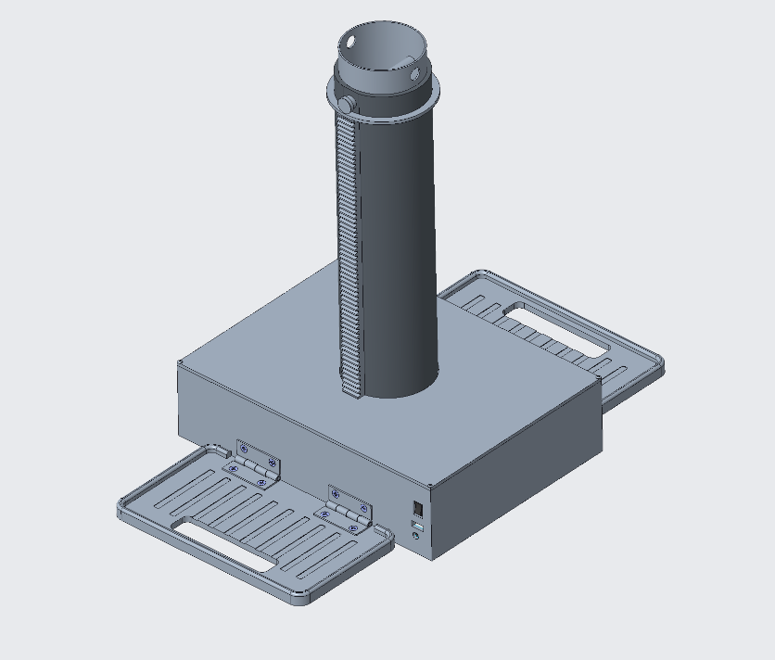

**Figure 22: TerraProbe Isometric View**

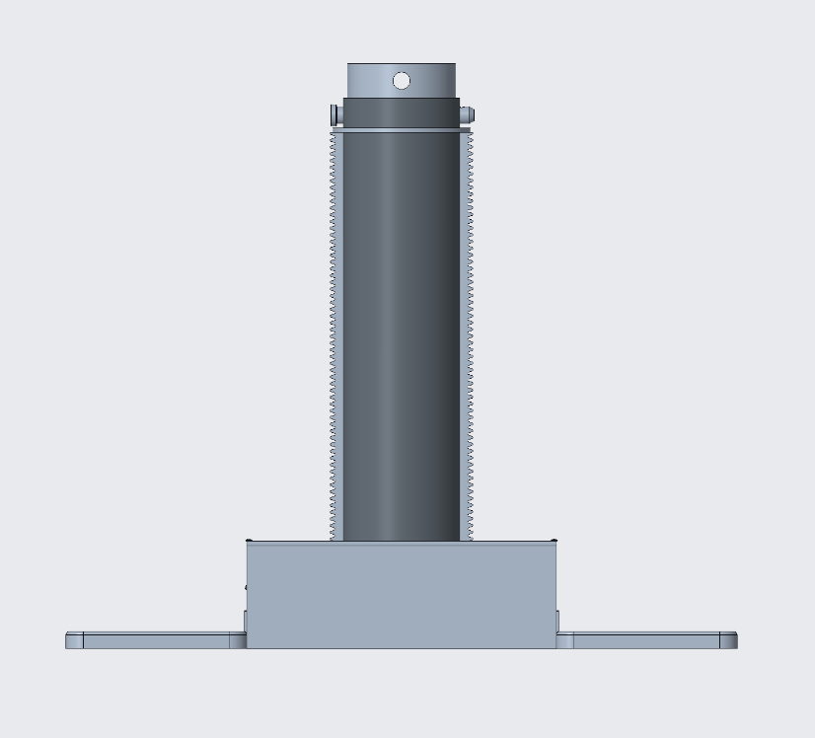

**Figure 23: TerraProbe Front View**

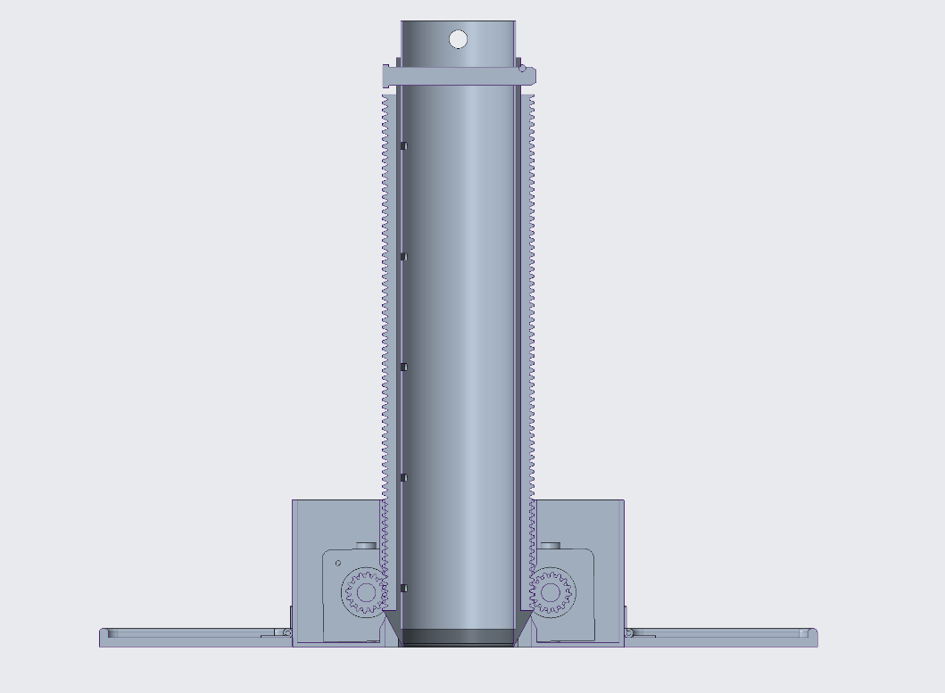

**Figure 24: TerraProbe Full Assembly Cross Section**

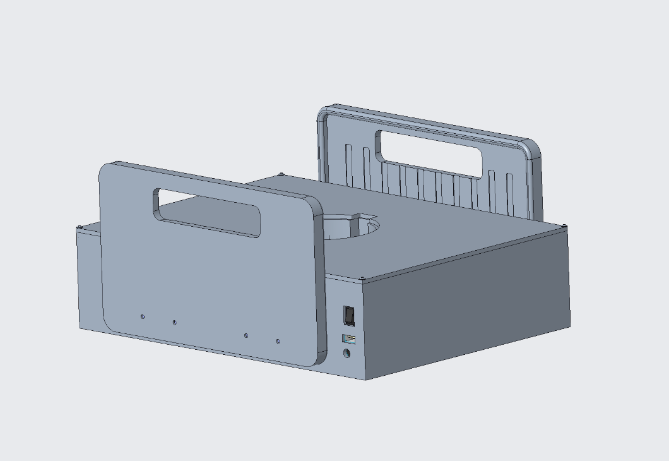

**Figure 25: TerraProbe Travel Mode**

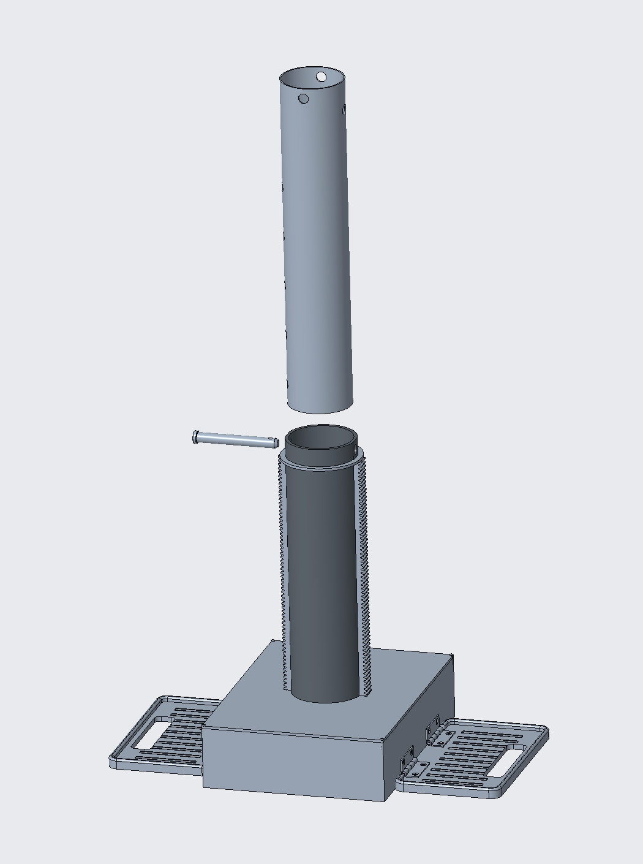

**Figure 26: TerraProbe Semi-Exploded Model**

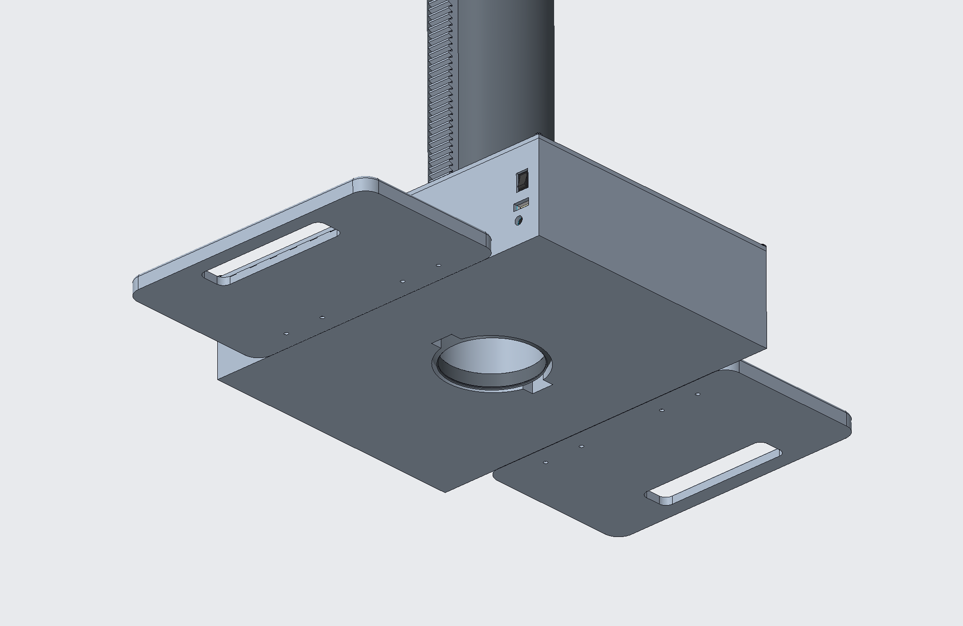

**Figure 27: TerraProbe Underside View**

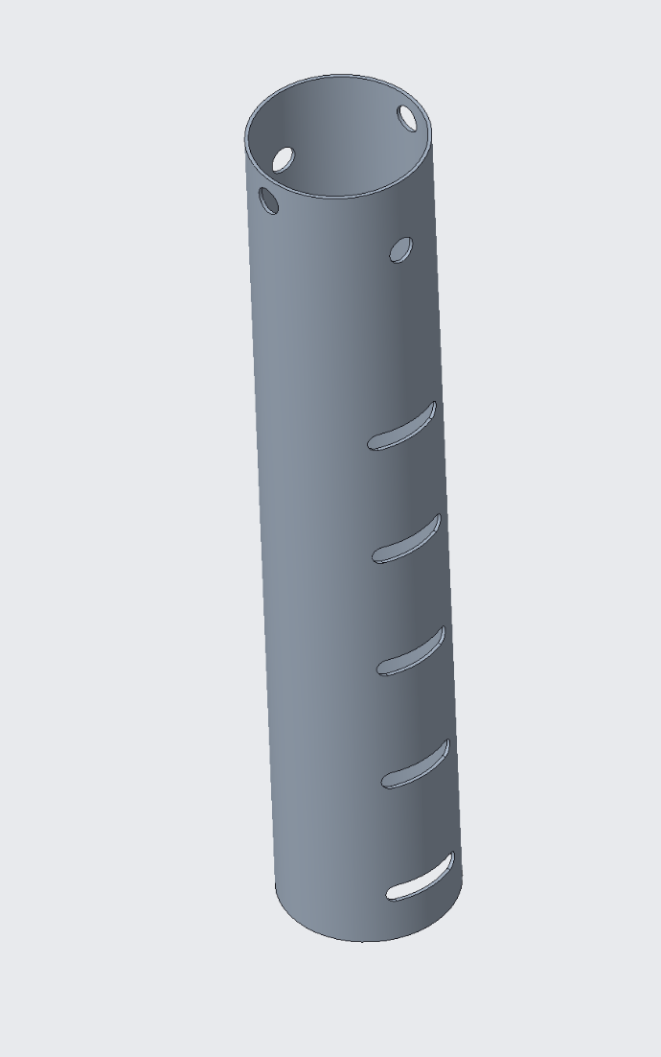

**Figure 28: Payload Chamber**

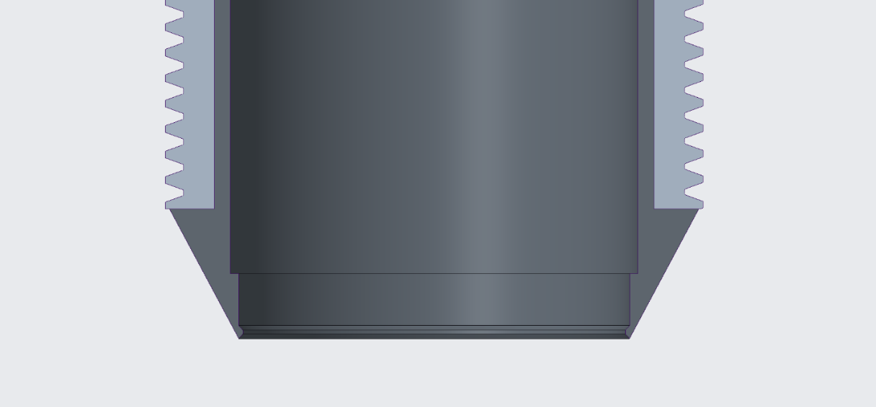

**Figure 29: Shell and Racks Close-Up Cross Section**

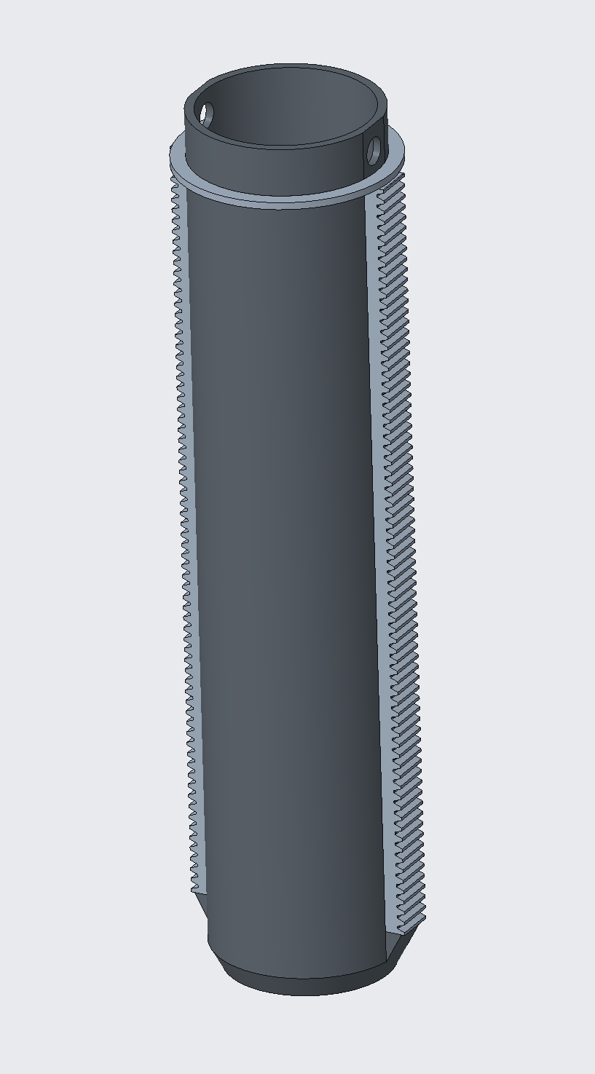

**Figure 30: Shell and Racks Sub-Assembly**

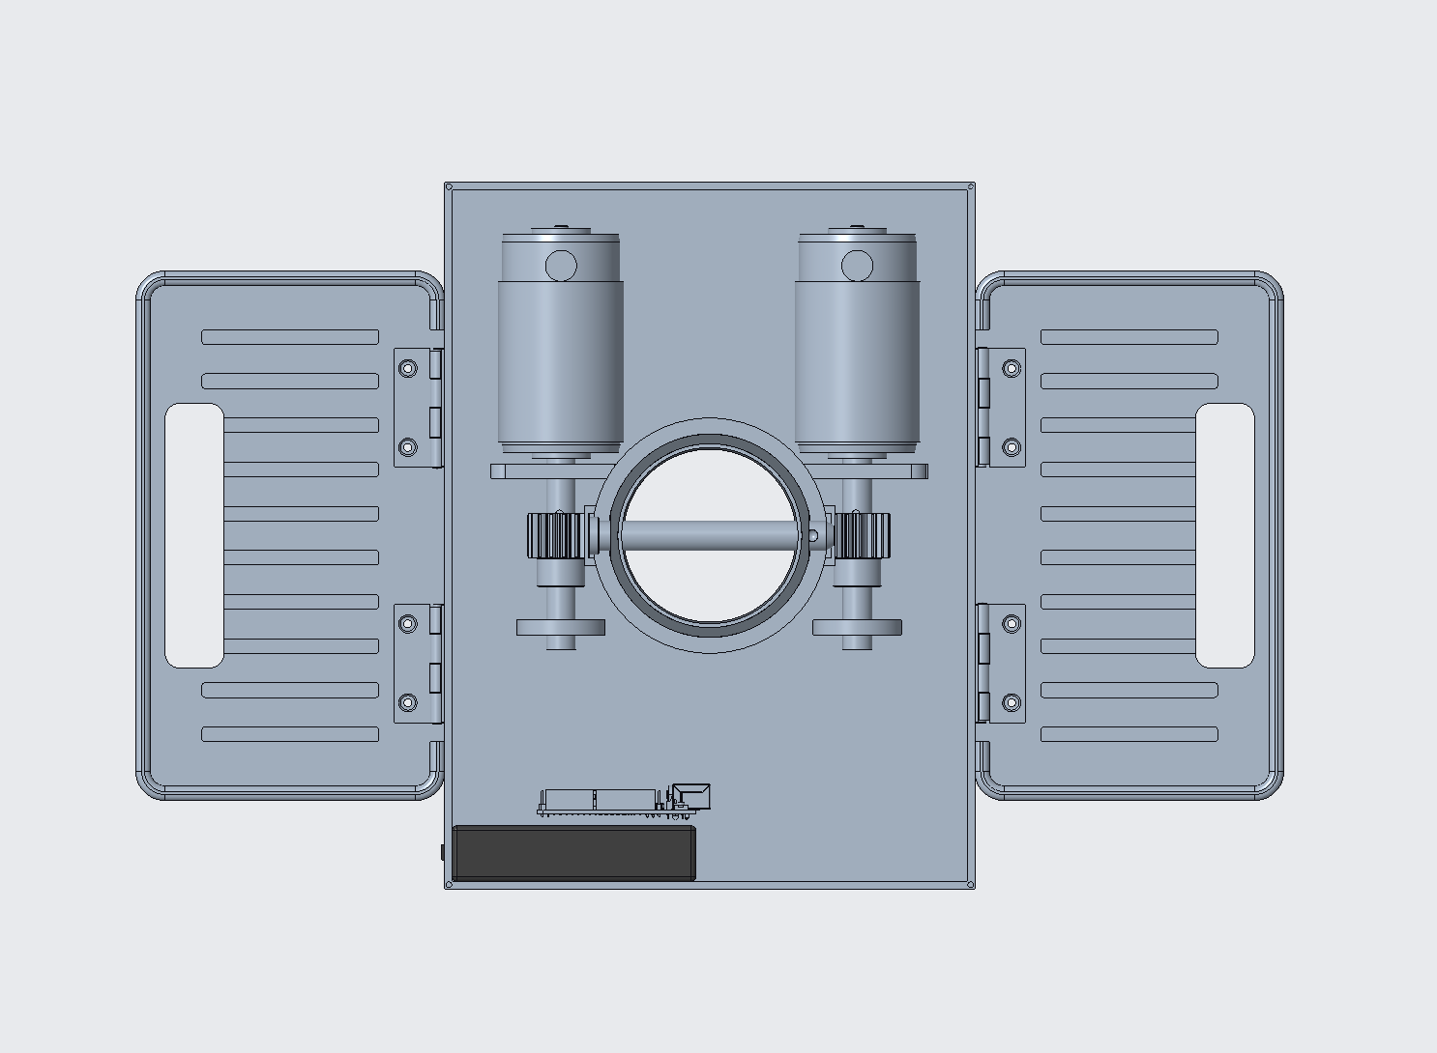

**Figure 31: TerraProbe Top View (Lid Off)**

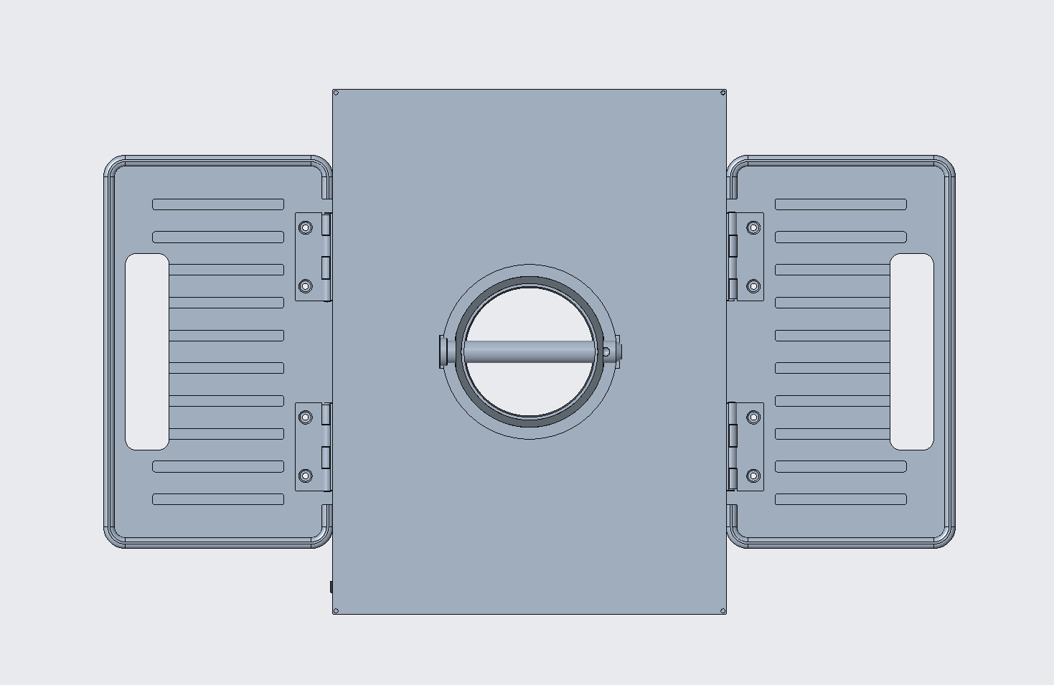

**Figure 32: TerraProbe Top View (Lid On)**

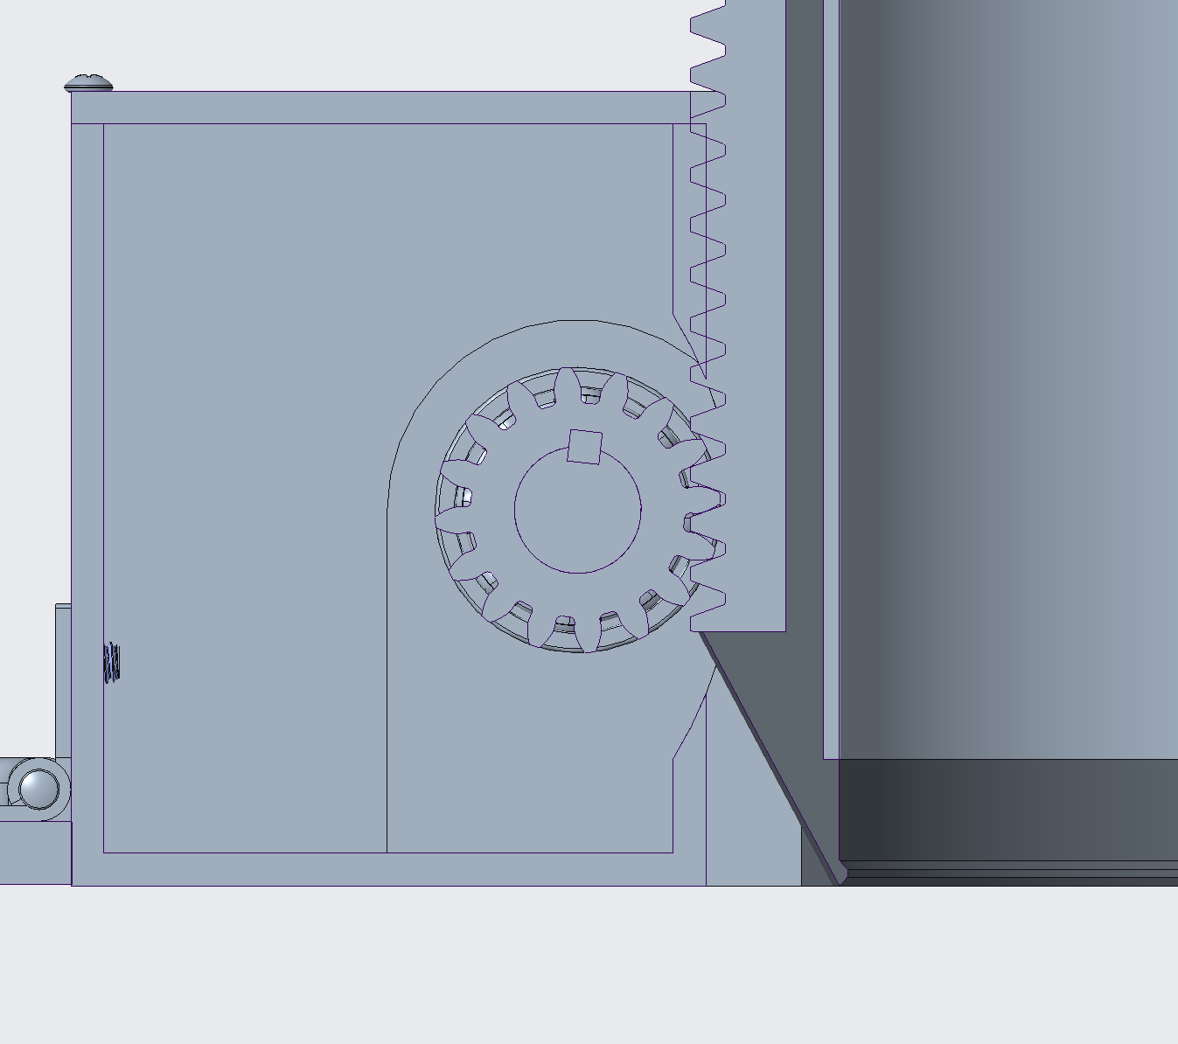

**Figure 33: Shaft, Key, and Pinion Close-Up**

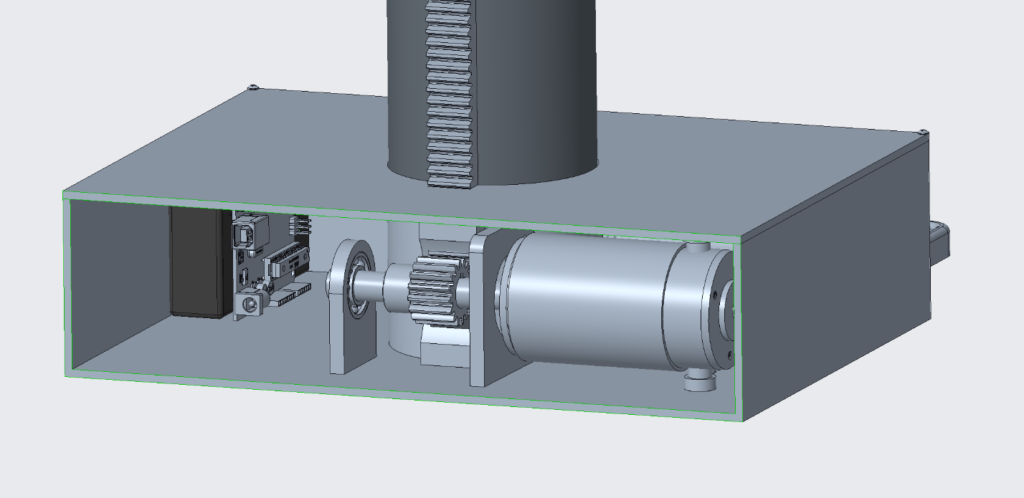

**Figure 34: TerraProbe Side View Cross Section**

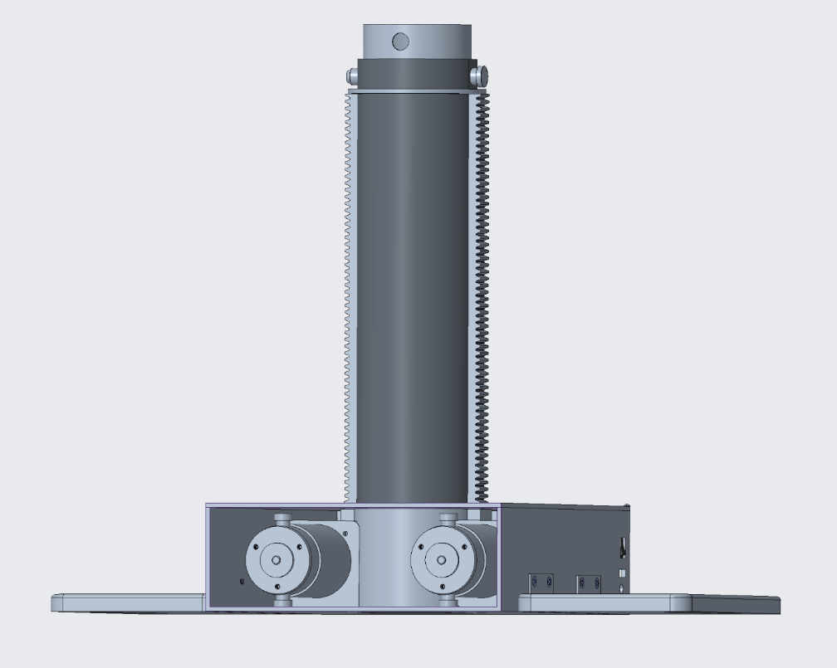

**Figure 35: TerraProbe Angled View (Front Panel Removed)**

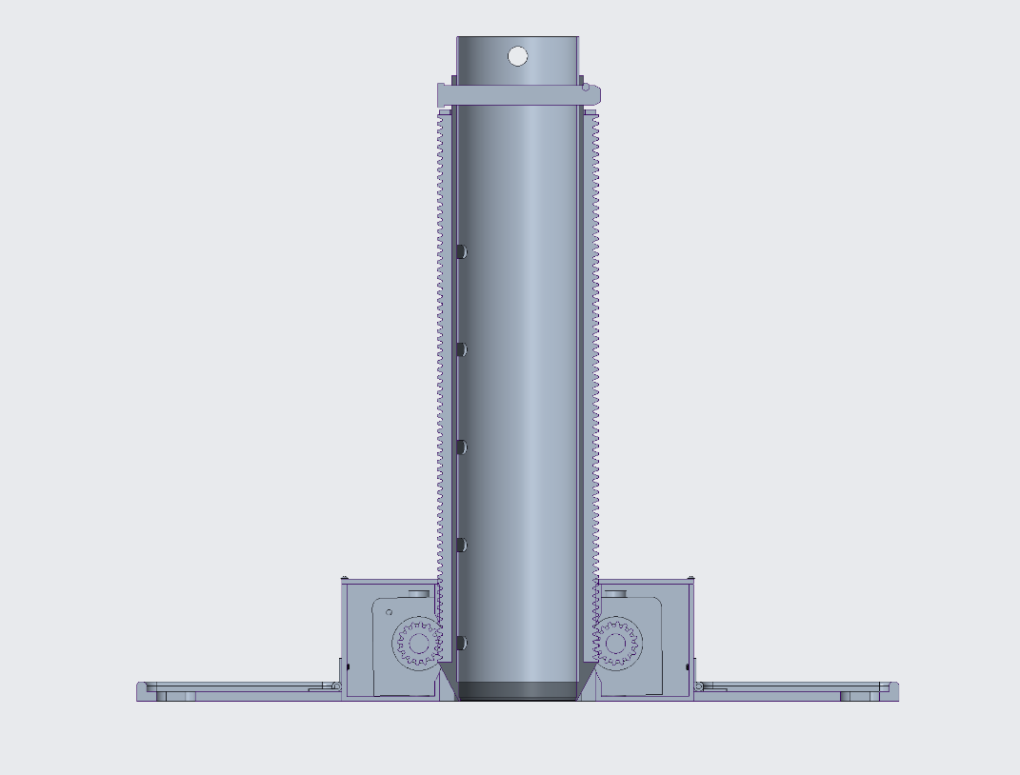

**Figure 36: TerraProbe Front View Cross Section**

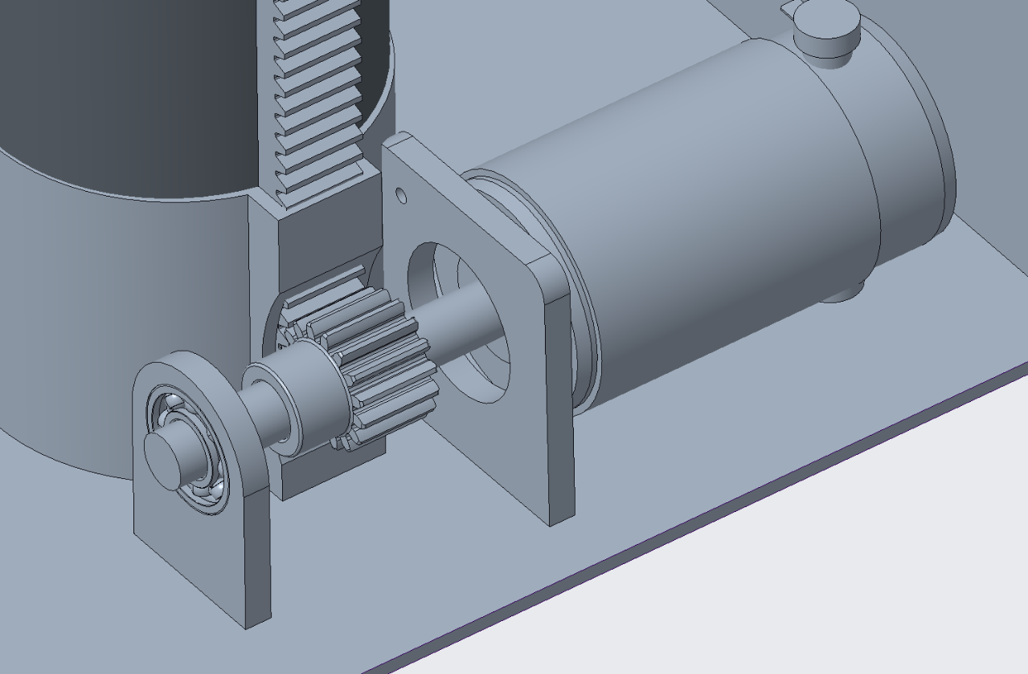

**Figure 37: Gear, Rack, and Pinion Close-Up**



**Figure 38: Soil Testing Probe (NPK & Moisture)**

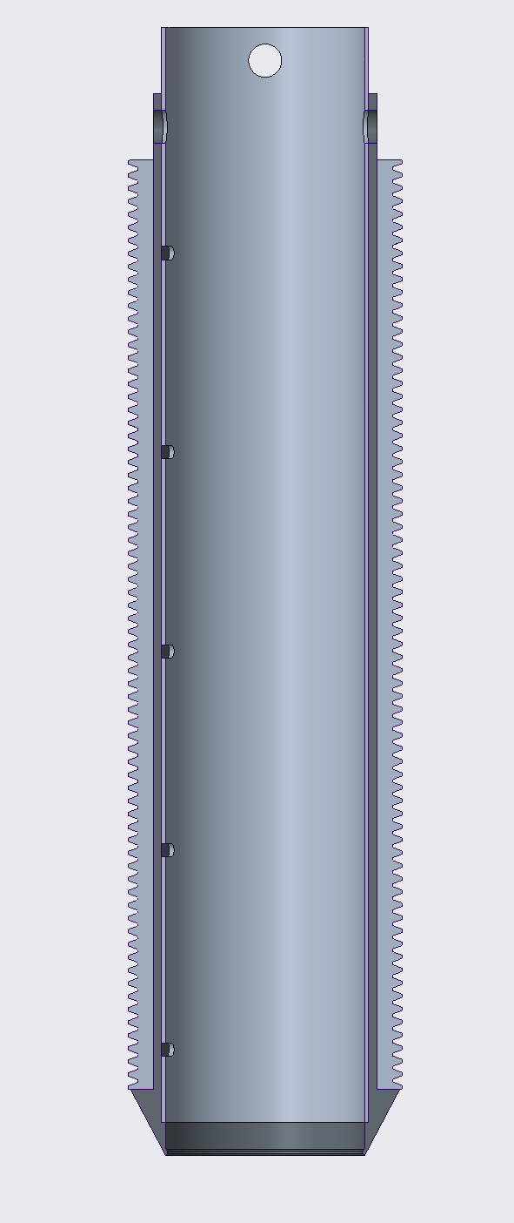

**Figure 38: Shell and Rack Sub-Assembly Cross Section**

**Figure 39: Electrical Diagram of Motor Controller System**

**Figure 40: Electrical Diagram of Soil Testing Probe (Data Acquisition System)**

**Figure 41: Design of Sample Dashboard Set-Up**

**Table 4. Make or Buy Table with Justifications**

|  |  |  |
| --- | --- | --- |
| **Component** | **Make/Buy** | **Justification** |
| Inner Payload | Make | Requires specific shapes that are best controlled in-house. |
| Outer Payload | Make | Custom design requirements make in-house production preferable. |
| Sensor Probe Casing | Make | Custom casing ensures proper fit for sensors and electronics. |
| Foot Pedals | Make | Custom design is required to meet project needs. |
| Sensors | Buy | Precision components that are not feasible to manufacture. |
| Electronics | Buy | Specialized components requiring external sourcing. |
| Batteries | Buy | Standardized and regulated components best sourced externally. |
| Gears | Buy | Complex manufacturing process and high production cost. |
| Shafts | Buy | Bought at standard size and manufactured as needed by ME shop. |
| Motors | Buy | Precision-engineered components requiring external expertise. |

1. **Analysis**

**Required Tangential Force from Gears**

This section lays out one model that could be used to analyze the required Torque/Force to push the robot the required height into the soil. To determine all the forces that acted on the robot body, a free body diagram was used



**Figure XX: Free Body Diagram**

* $g=9.81 ms^{-2}$ is the gravitational acceleration
* $a$ is the internal side length of the internal payload
* $b$ is the external side length of the external guidance system
* $A_{o}=a^{2}$ is the external cross-sectional area
* $A_{i}=b^{2}$ is the internal cross-sectional area
* $z$ is the depth into the soil
* $A_{s,o}=4az$ external surface area exposed to soil
* $A_{s,i}=4bz$ internal surface area exposed to soil
* $M$ is the mass of the robot unit
* $W_{robot}=Mg$ is the weight of the robot unit
* $θ$ is the angle of the chamfer at the bottom
* $∆z$ is the height of the chamfer
* $A_{slant}$ is the surface area of the chamfer
* $γ$ is the unit weight of the soil
* $ρ$ is the density of the soil
* $c^{'}$ is the effective cohesion coefficient of the soil
* $Փ$ is the friction angle of the soil
* $m= ρA_{i}z$ is the mass of the collected soil
* $W_{soil}= mg$ is the weight of the collected soil
* $F$ is the required input force (we are solving for this)
* $f_{o}$ is the external friction
* $f_{i}$ is the internal friction
* $F_{soil,static}$ is the “soil-static” pressure on the chamfer

Using the free body diagram, we can find the equation of motion in the $z$ direction and that would be our governing equation

$\sum{F_{z}=2F+f_{i}+W_{robot}+W_{soil}}-f_{o} -F_{soil_{static}}=\left(m+M\right)\ddot{z}$ $\left(1\right)$

We need to ensure that $\ddot{z}$ (the acceleration) is always greater than or equal to zero until the desired height is reached. Once that is solved, the robot can be run at reverse at the same Force/Torque. However, there remain many unknowns: $f_{i}, f_{o}, and F_{soil_{static}}$. According to Purdue University, the following equations can be used to determine the unknowns

$f_{i}=N_{i}\tan\left(Փ\right)$ $\left(2\right)$

$f_{o}=N_{o}\tan\left(Փ\right)$ $\left(3\right)$

Where $N_{i}$ and $N_{o}$ are the normal forces acting on the internal and external walls respectively (the hydrostatic equivalent force on each of the 4 sides of the walls)

$N_{i}=\frac{1}{2}(P_{i}A_{s,i})$ $\left(2.1\right)$

$N_{O}=\frac{1}{2}(P_{o}A_{s,o})$ $\left(3.1\right)$

Where $P_{i}$ and $P_{o}$ are the maximum lateral pressure acting on the internal and external surface respectively. The pressure can be calculated from the Active and Passive earth theory (Purdue et.al). Since the robot is moving through the soil on the external surface, it would experience passive pressure. On the other hand, since the soil is moving through the internal surface, it would experience active pressure. The equations can be seen below

$P_{i}=K_{a}γz-2c^{'}{\left(K_{a}\right)}^{\frac{1}{2}}$ $\left(2.2\right)$

$P_{o}=K_{p}γz+2c^{'}{\left(K_{p}\right)}^{\frac{1}{2}}$ $\left(3.2\right)$

The active and passive pressure coefficients ($K_{a}, K_{p}$) can be calculated using the friction angle

$K_{a}=\frac{1-sin⁡(Փ)}{1+sin⁡(Փ)}$ $\left(2.3\right)$

$K_{p}=\frac{1+sin⁡(Փ)}{1-sin⁡(Փ)}$ $\left(3.3\right)$

There remains one unknown which is the $F_{soil,static}$. This can be treated as a simple pressure distribution case and the equation below can be used to solve the same

$F_{soil,static}=\frac{1}{2}\left(K_{p}γ\left(2z+∆z\right)+4c^{'{\left(K_{p}\right)}^{\frac{1}{2}}}\right)A_{slant}$ $\left(3\right)$

Using these equations, we can determine the minimum required force by pre-determining the desired motion profile. However, it is important to make note of the assumptions we made to derive the equation

* The soil is a homogenous substance (soft cohesive soil)
* Soil has negligible water content
* Soil has constant properties
* Gear rack surface area << than surface area of payload
* Internal friction is considered negligible due to the creation of a “lip” at the bottom of the internal payload
* Assume cohesion ~ 20 KPa (typical property of loamy soil)
* Friction on cone tip is << friction on the entire surface
* $A_{slant}$ << $A_{s,o} or A_{s,i}$

So, from the above model we estimate that the force required from each motor will be around **~925 N (207.9 lbf)** ; This value can vary significantly as the cohesion value greatly changes our results.

**Figure 27: Desired Motion Profile with constant velocity**

**Figure 28: Resulting Required Force over time to reach the desired depth**

**Failure analysis for Rack and Pinion mesh**

To design the rack and pinion system, the minimum number of teeth on the pinion needed to be determined to avoid undercutting. This can be seen in the equation below

$$\left(eq 13-10\right) N_{p }=\frac{2\left(k\right)}{\sin^{2}{Փ}}$$

Where $N_{p }$ is the minimum number of teeth on the pinion, $k (contact ratio)=0.9$, and $Փ$ is the pressure angle. Plugging in $Փ={20}^{o}$ and rounding up to the nearest whole number, we get that $N_{p }=16$. Since the team needs a large tangential force and the gear needed to be small, we chose a gear with a diameter of 1 inch. This results in an equivalent transversal pitch (of both the rack and the pinion), $P_{d}=\frac{N_{p}}{d_{p}}=16$. Using the equation below, we can then determine the pitch line velocity of the 2-gear mesh

$$\left(eq 13-34\right) V= \frac{πdω}{12}$$

Where $V$ is the pitch line velocity in ft/min, $d$ is either pinion/gear diameter in inches, and $ω$ is either the angular velocity in rpm of the pinion/gear. Substituting the relevant values, we get $V= 7.20 ft/min$. Furthermore, we can use the equation below to determine the tangential load acting between the mesh

$$\left(eq 13-35\right) W^{t}= \frac{33000H}{V}$$

Where $W^{t}$ is the tangential load in lbf, and $H$ is the power generated in Horsepower. This equation is crucial in motor selection as $W^{t}$ would need to be a minimum of 207 lbf. A motor that ran at 35 W, had a rated rpm of around 30 rpm was chosen. Substituting the relevant values, we get $W^{t}= 213. 90 lbf$. Finally, using Table 13-3 from shigley’s, the face width needed to be a minimum of $F=\frac{10}{16}=0.62 in$ for both the rack and the pinion. Now that the key variables have been determined, we can move on to stress and factor of safety analysis. AGMA recommends using a quality factor $Q_{v}=7$ and Reliability $R=99\%.$ The desired life was decided as $N={10}^{6}$.Since we know the pinion is likely to fail first, due to having going through more loading cycles than the rack, if we design for the pinion to not fail, the rack will not fail either. The gear contact stress can be written as shown in equation 26 and the gear bending stress can be seen in the equations below

$$\left(eq 14-16\right) σ_{c}=C_{p}{\left(W^{t}K_{o}K_{s}K_{v}*\frac{K_{m}}{F*d_{p}}*\frac{C_{f}}{I}\right)}^{\frac{1}{2}}$$

$$\left(eq 14-15\right) σ=W^{t}K_{o}K_{s}K_{v}*\frac{P_{d}}{F}*\frac{K_{m}K_{b}}{J}$$

Each key variable and constant are listed in Table XX below along with how the constants were found.

**Table XX: Key Variables and Constants for Contact Stress and Bending Stress analysis *Check python attached in appendix for the calculations**

|  |  |  |  |
| --- | --- | --- | --- |
| Variable/Constant | Physical Meaning | Numeric Value | Shigley Source |
| $$σ_{c}$$ | Gear Contact Stress | $$62.67 kpsi$$ | eq 14-16 |
| $$σ$$ | Gear Bending Stress | $$26.56 kpsi$$ | eq 14-15 |
| $$C_{p}$$ | Elastic Coefficient | $$2300 psi^{\frac{1}{2}}$$ | Table 14-8 |
| $$W^{t}$$ | Tangential Load | $$213.90$$ | eq 13-35 |
| $$K_{o}$$ | Overload Factor | $$1.00$$ | ANSI/AGMA standard |
| $$K_{s}$$ | Size Factor | $$1.00$$ | ANSI/AGMA standard |
| $$K_{v}$$ | Dynamic Factor | $$1.03$$ | eq 14-27 |
| $$K_{m}$$ | Load Distribution Factor | $$1.19$$ | eq 14-30 |
| $$K_{b}$$ | Rim Thickness Factor | $$1.29$$ | eq 14-40 |
| $$F$$ | Face Width | $$0.75 in$$ | table 13-3 |
| $$d_{p}$$ | Pinion Diameter | $$1.00 in$$ | Problem Statement (Term Project) |
| $$P_{d}$$ | Transversal Pitch | $$5.00 teeth/in$$ | ANSI/AGMA Standard |
| $$C_{f}$$ | Surface Condition Factor | $$1.00$$ | ANSI/AGMA Standard |
| $$I$$ | Geometry Factor | $$0.47$$ | eq 14-23 |
| $$J$$ | Geometry Factor | $$0.27$$ | fig 14-6 |

Now that the stresses have been determined, the fatigue factor of safety can be computed using the equations seen below

$$\left(eq 14-42\right) S_{H}=\frac{S_{c}Z_{N}C_{H}}{K_{T}K_{R}σ_{c}}$$

$$\left(eq 14-41\right) S_{T}=\frac{S_{t}Y_{N}}{K_{T}K_{Rσ}}$$

To begin with, the material chosen was AISI Steel 1144, Hardened as it has the lowest strength hence presents the cheapest option. A table with all the key variables/constants is present below

**Table XX: Key Variables and Constants for Factor of safety analysis**

|  |  |  |  |
| --- | --- | --- | --- |
| Variable/Constant | Physical Meaning | Numeric Value | Shigley Source |
| $$S_{H}$$ | Wear Factor of Safety | $$1.81$$ | eq 14-42 |
| $$S_{T}$$ | Bending Factor of safety | $$3.49$$ | eq 14-41 |
| $$Z_{N}$$ | Stress Cycle Factor | $$1.05$$ | fig 14-15 |
| $$Y_{N}$$ | Stress Cycle Factor | $$1.04$$ | fig 14-14 |
| $$C_{H}$$ | Hardness ratio Factor | $$1$$ | section 14-12 (gear only assumption) |
| $$K_{T}$$ | Temperature Factor | $$1$$ | ANSI/AGMA Standard (T<250 F) |
| $$K_{R}$$ | Reliability Factor | $$1.00$$ | eq 14-38 |
| $$S_{t}$$ | Bending Strength | $$89 kpsi$$ | MatWeb |
| $$S_{c}$$ | Contact Strength | $$108 kpsi$$ | MatWeb |

The desired factor of safety was minimum of 1.5. From Table 12, we see that both the wear and bending factors of safety are greater than 1.5, Hence, AISI 1144 Steel gears would satisfy the design requirements

**Shaft Design**

The shafts will be designed first as the keys and bearings will be dependent on the design of the shaft. The input shaft is connected to a motor unit through a 1-inch diameter connection. Our first step will be to find the bending moment and shear force load across the shaft. To do this, we will start with finding the reaction forces and creating bending moments and shear diagrams.

Figure XX: Shaft Design Free-Body Diagram

The Figure above shows the forces acting on the shaft. There are 3 main forces: motor assembly reaction forces, tangential load provided by the gear, and the bearing reaction forces. Reaction Forces at Bearings ($B_{1_{y}}, B_{1_{z}}$). We can sum the moments and force to yield the reaction forces at bearings, considering the specified loads and connections. From the torque and gear calculations, we know that 958.3 N is the gear tangential force in the y-direction. With a gear angle of 20 degrees, we can find the gear force in the z-direction as well. The reaction forces below show the calculated values:

Therefore, our reaction forces for vectors $R_{1} and B_{1}$ become the following:

$$R_{1}=\left(124.3j+45.2k\right) lbf$$

$$B_{1}=\left(89.6j+32.6k\right)lbf$$

We can also calculate the torque that is applied to the system using radius of the pinion (0.5 in) and the force that is applied on the gear (Wt):

$$T=\left(0.5 in\right)\left(-239.6 lbf k\right)→T=-106.95 lbf in$$

The Shear, Bending Moment, and Torque Diagrams for x-y planes are illustrated, aiding in understanding loading conditions.

Figure XX: Shear Diagram y-direction

Figure XX: Shear Diagram z-direction

Figure XX: Bending Moment Diagram y-direction

Figure XX: Bending Moment Diagram z-direction

Figure XX: Combined Bending Moment Diagram

Figure XX: Torque Diagram for Shaft

From the maximum moment values generated, we can examine how our shaft will perform at high stress areas particularly the gear-key mechanism. We can calculate the alternating and mid-range values for torque and moment at key points of interest. The equations below show the formula for calculating the alternating and mid-range values:

$M_{a}=\frac{(M_{max}-M_{min})}{2}$ $M_{m}=\frac{(M_{max}+M_{min})}{2}$

$T_{a}=\frac{(T_{max}-T_{min})}{2}$ $T_{m}=\frac{(T_{max}+T_{min})}{2}$

Based on these critical points and obtained alternating/mid-range moment and torque values, we can calculate the Von-Mises stress at each of the points of interests. The Von-Mises stress can be calculated based on the following equation shown below. Since we know that $M_{m}$ and $T_{a}$ are 0 lbf in at all points of interest, we can further simplify these equations:

$$σ_{a}^{'}={{[(\frac{32K_{f}M_{a}}{πd^{3}})}^{2}+3{(\frac{16K_{fs}T_{a}}{πd^{3}})}^{2}]}^{\frac{1}{2}}→σ_{a}^{'}={(\frac{32K_{f}M_{a}}{πd^{3}})}^{2}$$

$$σ_{m}^{'}={{[(\frac{32K_{f}M_{m}}{πd^{3}})}^{2}+3{(\frac{16K_{fs}T_{m}}{πd^{3}})}^{2}]}^{\frac{1}{2}}→{σ_{m}^{'}=[3{(\frac{16K_{fs}T_{m}}{πd^{3}})}^{2}]}^{\frac{1}{2}}$$

In order to adequately solve the Von-Mises stresses, we need to also find information such as the diameters at the points of interest and the stress concentration factors at critical points such as keys based on moment and torque loadings. The diameter of the shaft will be 0.5 inches throughout the length of the shaft.

At the point of interest x = 1.37 inch along the shaft, we have a key to connect the gear to the shaft. Using Table 7-1 from Shigley, we find the end-mill key seat (r/d = 0.02) stress concentration factors as the following. We will also assume that $K_{t}=K_{f}$, which yields a notch sensitivity of 1:

$K_{t}= 2.14$ $q=1$

$K_{ts}= 3$ $q_{s}=1$

$$K_{f}=1+1\left(2.14-1\right)=2.14$$

$$K_{fs}=1+1\left(3-1\right)→K_{fs}=3$$

The calculations were performed in Python using the above equations. The table below represents the values that we obtained based on the input specified above.

**Table 1: Stress Values at Points of Interest**

|  |  |  |  |  |  |  |
| --- | --- | --- | --- | --- | --- | --- |
| X [in] | $$σ_{a} [psi]$$ | $$σ_{m} [psi]$$ | $$τ_{a} [psi]$$ | $$τ_{m} [psi]$$ | $$σ_{m}^{'} [psi]$$ | $$σ_{a}^{'} [psi]$$ |
| 1.37 | 3166.26 | 0 | 0 | 4357.66 | 22643.08 | 6775.81 |

Now finally using these von-misses stresses, we can calculate the fatigue factor of safety to check if infinite life is predicted and calculate the yield factor of safety to check for first cycle yielding. It is important to remember that we assumed that the material is AISI 4140 steel with Sut = 225 kpsi and Sy = 208 kpsi. The equations below show how the calculation for fatigue and yield factor of safety:

$$n_{f}={(\frac{σ_{a}^{'}}{S_{e}}+\frac{σ_{m}^{'}}{S_{ut}})}^{-1}$$

$$n_{y}=\frac{S_{y}}{σ_{a}^{'}+σ_{m}^{'}}$$

Looking at the above equations, all of the parameters are known for each point of interest except $S_{e}$, which is the endurance limit, the limit that tells us that if the part is operator under certain stress, it is predicted for infinite life.

The endurance limit can be calculated as shown:

$$Se=k_{a}k_{b}k_{c}k_{d}k_{e}Se'$$

$$Se^{'}=0.5*S_{ut}→Se^{'}=0.5\left(225\right)=112.5 kpsi (Eq 6-10)$$

$$k_{a}=2{(S_{ut})}^{-0.217}→k_{a}=2{(225)}^{-0.217}=0.617 (Cold-Drawn)(Eq 6-18)$$

$$k_{b}=0.879d^{-0.107} (Dependent on diameter)(Eq 6-19)$$

$$k_{c}=1 (combined loading)(Eq 6-25)$$

$$k_{d}=1 (assume room temperature)$$

$$k_{e}=1 (assume 50\% reliability)(Table 6-4)$$

Using these calculations to calculate endurance limit, along with the von-misses stresses and the ultimate strength of the chosen material, the following factor of safety values are obtained for each point of interest:

|  |  |  |
| --- | --- | --- |
| X [in] | $n_{f}$– Fatigue Factor of Safety | $n_{y}$– Yield Factor of Safety |
| 1.37 | 4.43 | 8.8 |

By approximating and choosing a diameter, we tested all the critical points (points of interest) for fatigue and yield failure. We can choose a design factor of 1.5 to ensure that the part won’t fail and since the fatigue and yield factor of safety values were greater than 1.5, we can successfully design the shaft with the following values.

**Key Design**

To design the key, we need to consider both the failure due to shear and failure due to crushing. The formulas to determine the corresponding factors of safety and stress can be seen below

$${\left(17\right) n}_{τ}=\frac{S_{sy}}{τ}=\frac{0.577S_{y}}{τ},τ=\frac{T}{rwl}$$

$$\left(18\right) n_{c}=\frac{S_{y}}{σ_{c}},σ_{c}=\frac{2T}{hrl}$$

Where $n_{τ}$ is the shear factor of safety, $n_{c}$ is the crushing factor of safety, $S_{y}$ is the yield strength, $τ$ is the shear stress, $σ_{c}$ is the crushing stress, $r$ is the radius of the shaft, $w$ is the key width, $l$ is the key length, and $h$ is the key height. From part the shaft design section we know that the r = 0.5 in (1.0/2). To simplify the design, a square key will be used. According to table 7-6 from Shigley’s, a 3 in shaft could have square key dimensions $w=h=\frac{1}{8} in$. From the force analysis in the previous section, we know the torque at the point is $T=106 lbf.$ The only unknown left to solve for is the $l$. A desired factor of safety of 1.5 was set. The equations above can be rearranged and solved as follows

$$l≥\frac{{Tn}_{τ}}{0.577S_{y}rw} ↔l≥ 0.197 in$$

$$l≥\frac{{2Tn}_{c}}{S_{y}rh} ↔l≥ 0.228 in$$

To satisfy both inequalities let $l≥0.228 in$. Hence the final dimensions and the strength of the key on the input shaft are: (corresponding to McMaster Part # 98870A090)

$$w=0.125 in, h=0.125 in, l=0.25 in$$

**Bearing Design**

To enhance the safety of the shaft by keeping the gear in place, the design will house a bearing on the shaft. Using the bearing reaction forces and the design equation below, we can design a ball bearing for a given reliability, design life, and catalog life to find the catalog load.

$$a_{1}\left(C_{10}\right){\left(L_{10}\right)}^{\frac{1}{a}}=(F_{D}){(L_{D})}^{\frac{1}{a}}$$

Given a reliability of 90%, $a_{1}=1$, the design life $L_{D}=15000 hrs$, assume catalog life of ${10}^{6}$, and $a=3$ for ball bearings, we can calculate the design load based on the bearing reaction forces we calculated for the input shaft.

$$R_{B1}=\sqrt{{{(R}_{B1,y})}^{2}+{{(R}_{B1,z})}^{2}}→R_{B1}=95.37 lbf$$

Based on the following parameters, the catalog load ($C_{10}$) value can be calculated.

The bore diameter of the bearing needs to match the shaft diameter of the region which is 0.5 inch for this bearing. Using a McMasterCarr catalog, we can find a bore diameter of 0.5 inch that meets or exceeds the catalog load requirement obtained: *https://www.mcmaster.com/60355K291/ (Static Load Max: 530 lbf, Dynamic Load Max: 1140 lbf Max RPM: 25k)*.

1. **FMEA**
   1. The Failure Mode Effects Analysis file is attached called “FMEA_CDR.xlsx”

The Failure Modes and Effects Analysis (FMEA) identified key risks across various subsystems/subassemblies of the project, with a focus on the mechanical, electrical, and software components. The highest initial RPN values were observed in Power System Failure (270) and Motor Overheating (240) due to their severe impact on device functionality. Mitigation strategies, such as optimizing power consumption, incorporating backup batteries, and improving ventilation, were brainstormed and incorporated into the CDR design to reduce risk. Other critical issues, including Sensor Failure, Soil Water Ingress, and Loose Mechanical Couplings, were addressed through enhanced sealing, shock-resistant mounting, and reinforced fasteners. Following mitigation, the recalculated RPN values indicate a significant reduction in risk, improving system reliability and ensuring the device performs efficiently in real-world conditions.

1. **BOM & Sourcing Plan**

Budget_BOM.xlsx is attached to this document

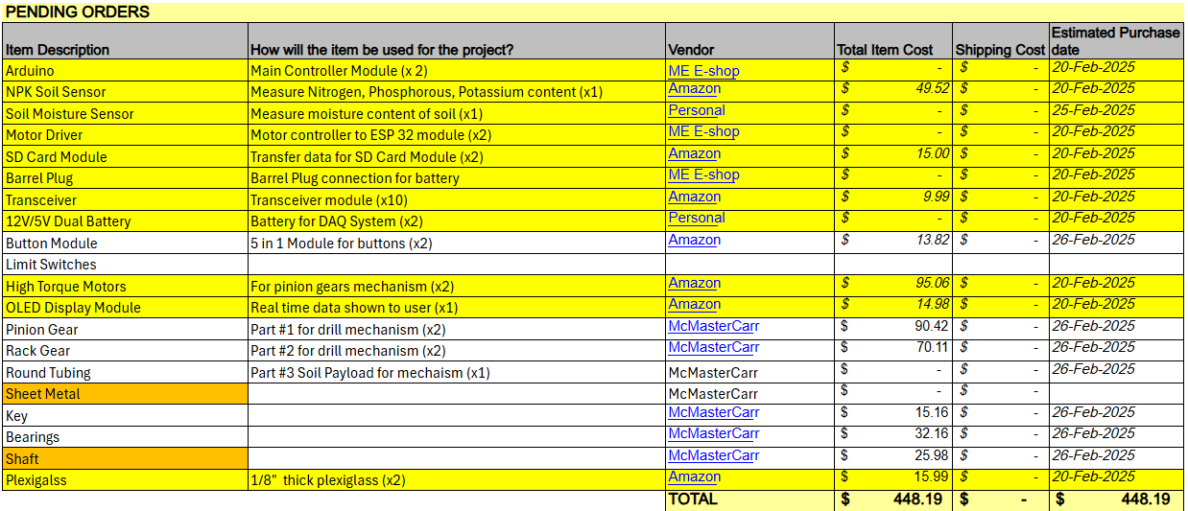

Apart from the above outlined materials, only the key for the gear will be made by the TerraProbe team. All other parts will be bought from the respective vendors listed.

1. **Validation Plan & Test Feasibility**

The testing and validation plan ensures that all components and subsystems function as expected, meet design tolerances, and integrate seamlessly. The plan focuses on validating individual components, testing mechanical and electrical aspects. By systematically testing smaller functional units before full integration, the project aims to achieve reliable operation

**Component Testing (Mechanical, Electrical, and Preliminary Validation)**

Component testing verifies the functionality and durability of individual parts before integration. This includes testing motors, sensors, mechanical components, and structural elements to ensure they meet performance standards under various conditions.

* Motors (Controller Design, Encoder Counts, Controls Testing)
  + Run motors at different speeds and monitor encoder feedback for performance accuracy.
  + Determine digital PWM to operate motor at desired conditions
  + Conduct system Identification and measure and set motors’ two percent settling time to approximately 1-2s
  + Design PI controller using motor as plant to measure and ensure steady state error
* Sensors – NPK, Moisture
  + Calibrate sensors using controlled soil samples with known nutrient and moisture levels.
  + Perform tests to validate measurements in extremely dry/moist soil
* OLED Display Panels
  + Display patterns/text to test brightness, contrast, and response time.
  + Run the display for long periods of time and check for any errors
  + Verify readability under different lighting conditions.
* Rack and Pinion
* Key/Gear/Shaft
  + Measure dimensions using calipers and micrometers for precision.
  + Conduct rotational testing to ensure smooth operation and identify any misalignment.
  + Apply torque testing to assess load-bearing capacity.
* Shaft/Motor System
* Test under various loads to monitor stability and performance.
  + Analyze wear and tear over prolonged operation.
  + Ensure fits are appropriate.
  + Conduct vibration testing to ensure mechanical stability.
* Structural Integrity (Casing, Pins, and Tolerances)
  + Verify the inner/outer casing fit using precision measurement tools.
  + Conduct environmental stress tests, submerging and removing the payload from soil

**System & Assembly Testing**

System testing evaluates how components function together. This phase ensures the complete system operates efficiently by validating motion mechanics, soil collection, and structural integrity.

* Motor-Pinion-Rack System
  + Run the full system under load to assess forward and backward movement
  + Analyze backlash, gear meshing, and alignment.
* Soil Collection Validation
  + Perform field tests in various soil types to ensure effective collection.
  + Compare collected samples against expected volume and consistency.
  + Validate automation for repeatability and efficiency.
* Weight Testing
  + Measure system weight in different operational states (with and without soil) and ensure the total weight is below the maximum limit
  + Ensure consistency through repeated trials with multiple soil types.
* Probe, Data, and Analytics
  + Compare collected probe data with reference values for accuracy.
  + Test data transmission and logging for reliability.
  + Analyze recorded data for inconsistencies and sensor drift – correct (if necessary) with Kalman Filters
* Sub-Assembly & Final Integration Testing
  + Conduct functional tests for sub-assemblies like the testing probe and shaft-pinion-rack before full integration.
  + Verify proper fit, alignment, and operational efficiency.
  + Perform final testing post-assembly to validate overall performance.
  + Conduct environmental stress tests, including temperature and humidity variations.
  + Perform insertion/removal force tests on pins to check ease of assembly and secure fitting.

1. **References**

Crop Nutrition. (n.d.). *Third-party soil sampling: What you need to know.* Retrieved

February 6, 2025, from <https://www.cropnutrition.com/resource-library/third-party-soil-sampling-what-you-need-to-know/>

North Carolina State University Extension. (n.d.). *Careful soil sampling: The key to reliable*

*soil test information.* Retrieved February 6, 2025, from <https://content.ces.ncsu.edu/careful-soil-sampling-the-key-to-reliable-soil-test-information>

Soil Science Society of America. (n.d.). *Self-study exam: Soil sampling and testing.*

Retrieved February 6, 2025, from <https://www.soils.org/files/certifications/certified/education/self-study/exam-pdfs/243.pdf>

Shigley, J. E., Mishke, C. R., & Budynas, R. G. (2021). *Shigley's mechanical engineering design* (13th ed.). McGraw-Hill Education.

California Department of Transportation. (2011). *Trenching and shoring manual*.

Retrieved February 6, 2025, from <https://engineering.purdue.edu/~frosch/ftp/Talbott/11%20-%20References/files/California%20Trenching%20and%20Shoring%20Manual.pdf>

CB Insights. (n.d.). *Agriculture tech trends*. Retrieved February 6, 2025,

from <https://www.cbinsights.com/research/agriculture-tech-trends/>

Engineering News-Record. (n.d.). *Market data*. Retrieved February 6, 2025,

from <https://www.enr.com/market_data>

Gartner. (n.d.). *Market research methodologies*. Retrieved February 6, 2025,

from <https://www.gartner.com/en/research/methodologies/market-research>

Grand View Research. (n.d.). *Soil testing market size, share & trends analysis report*.

Retrieved February 6, 2025, from <https://www.grandviewresearch.com/industry-analysis/soil-testing-market>

Grand View Research. (n.d.). *Smart agriculture market size, share & trends analysis report*.

Retrieved February 6, 2025, from <https://www.grandviewresearch.com/industry-analysis/smart-agriculture-farming-market>

International Food Policy Research Institute. (n.d.). *Publications*. Retrieved February 6,

2025, from <https://www.ifpri.org/publications>

Mordor Intelligence. (n.d.). *Geotechnical engineering market - growth, trends, COVID-19*

*impact, and forecasts*. Retrieved February 6, 2025,

from <https://www.mordorintelligence.com/industry-reports/geotechnical-engineering-market>

NASA. (n.d.). *Earth science*. Retrieved February 6, 2025,

from <https://science.nasa.gov/earth-science/>United Nations Environment

Programme. (n.d.). *Resources*. Retrieved February 6, 2025, from <https://www.unep.org/resources>

United States Department of Agriculture, Economic Research Service. (n.d.). *Home page*.

Retrieved February 6, 2025, from [https://www.ers.usda.gov](https://www.ers.usda.gov/)

The World Bank. (n.d.). *Agriculture and rural development*. Retrieved February 6, 2025,

from <https://data.worldbank.org/topic/agriculture-and-rural-development>

Envirotecnics. (2020). *AMS soil sampling*. Retrieved February 6, 2025,

from <https://www.envirotecnics.com/wp-content/uploads/2020/07/AMS-soil-sampling-envirotecnics.pdf>